1. What is the world database used for?

The world database stores the collection of organised information on cities, countries and country languages. This database allow us to access and query the data using sql language.

1. How many tables are there in the world database? There are three tables: city, country and countrylanguage.

Show tables;

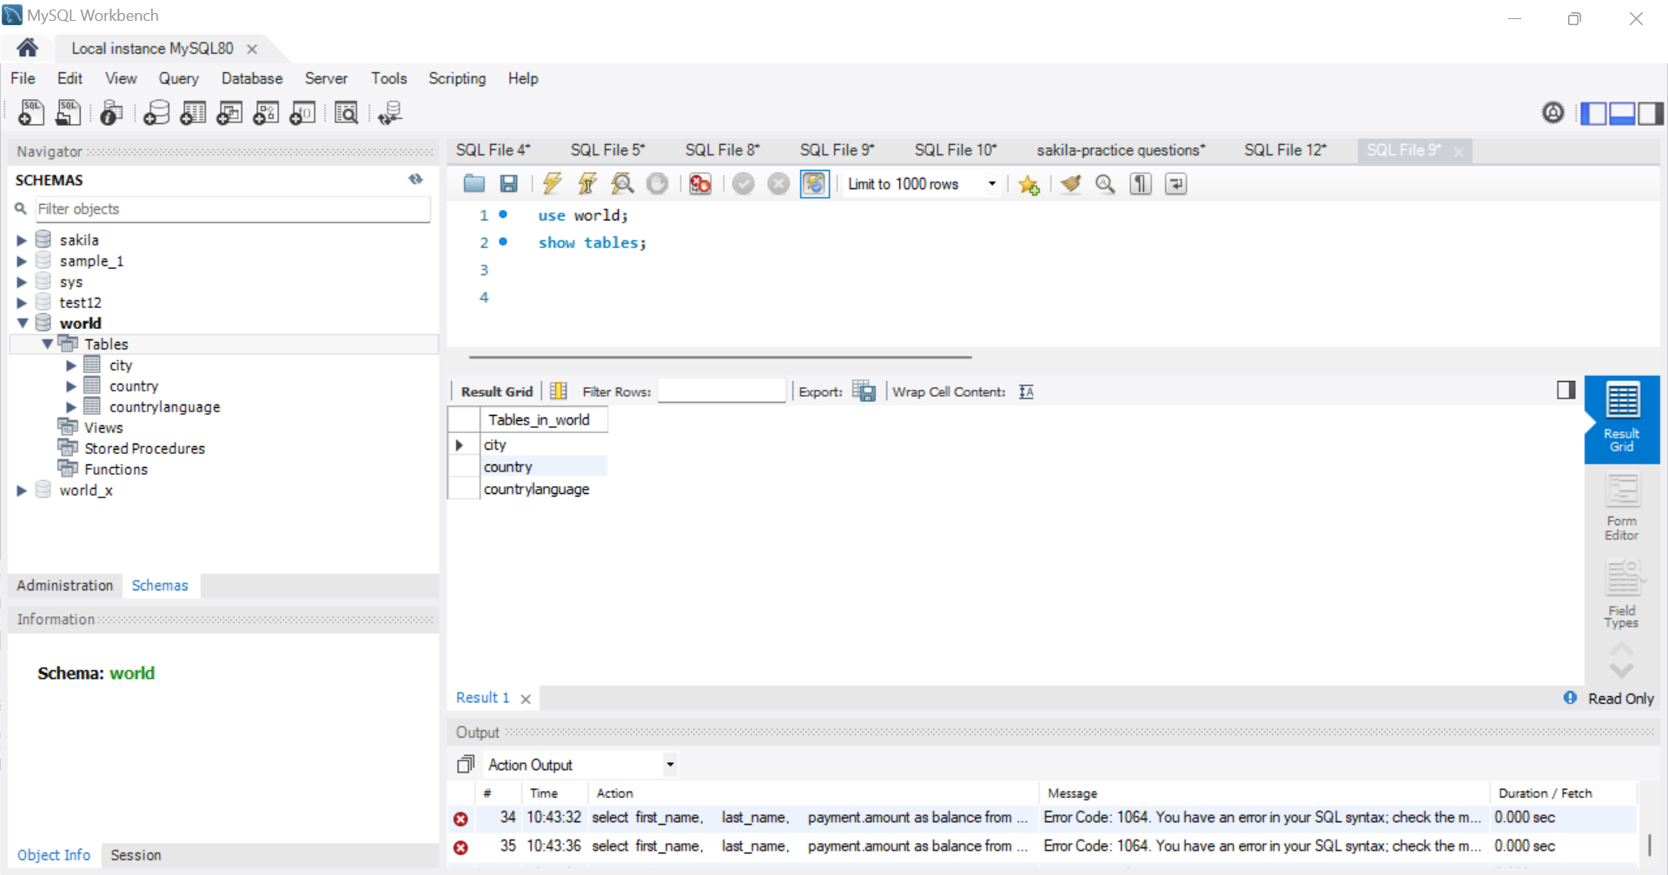

1. What does the city table store?

Select \* from city;

The city table stores five columns: ID, Name, CountryCode, District, and population columns.

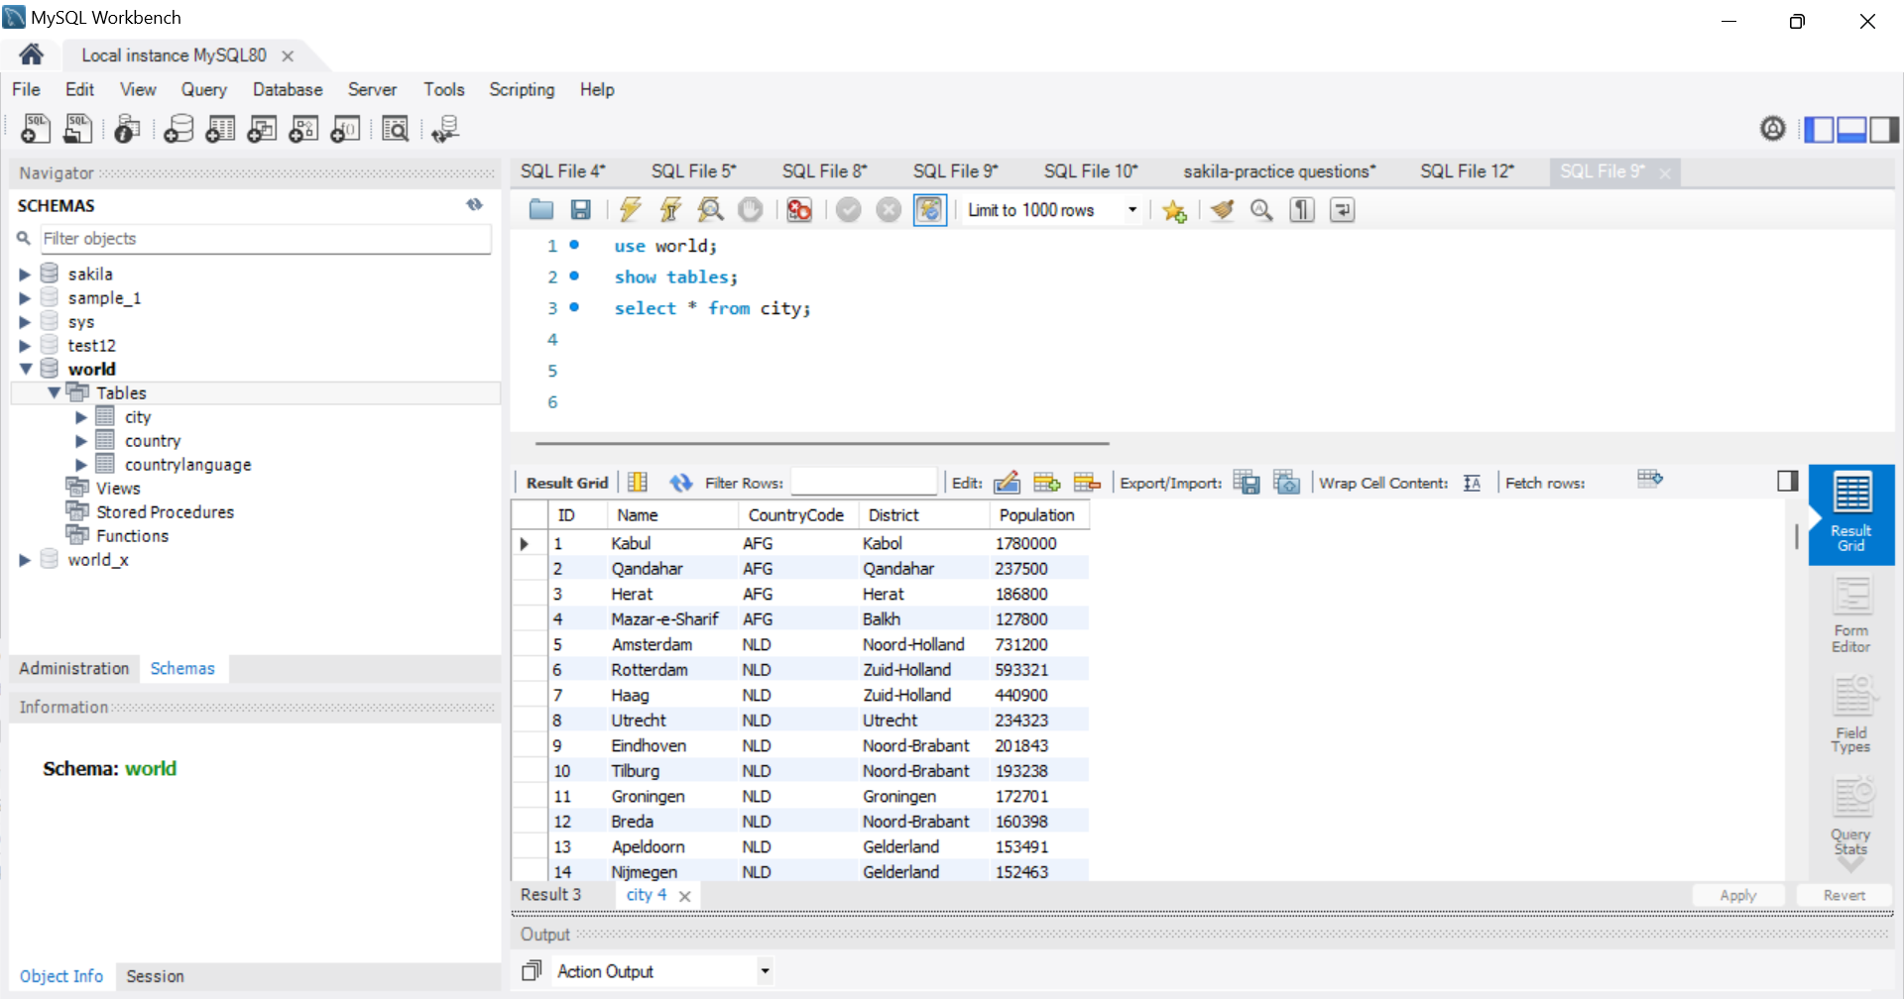

1. What does the country table store?

The country table stores the following columns:

Select \* from country;

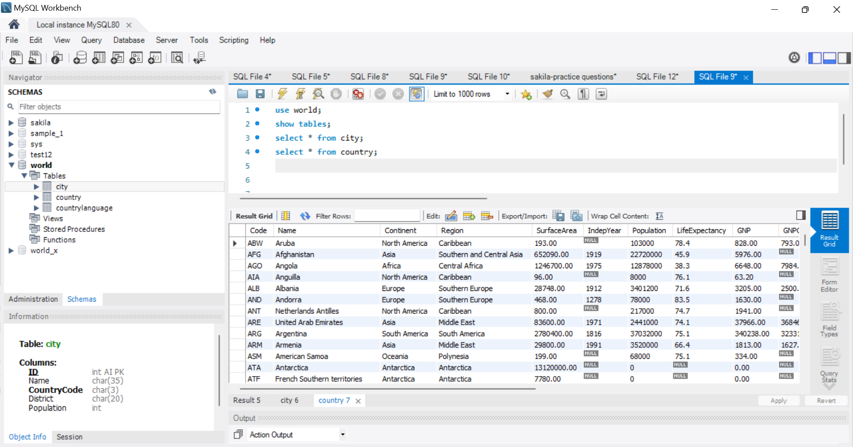

1. What does the countrylanguage table store?

Select \* from countrylanguage;

The countrylanguage table store these columns: CountryCode, Language, IsOfficial, and Percentage.

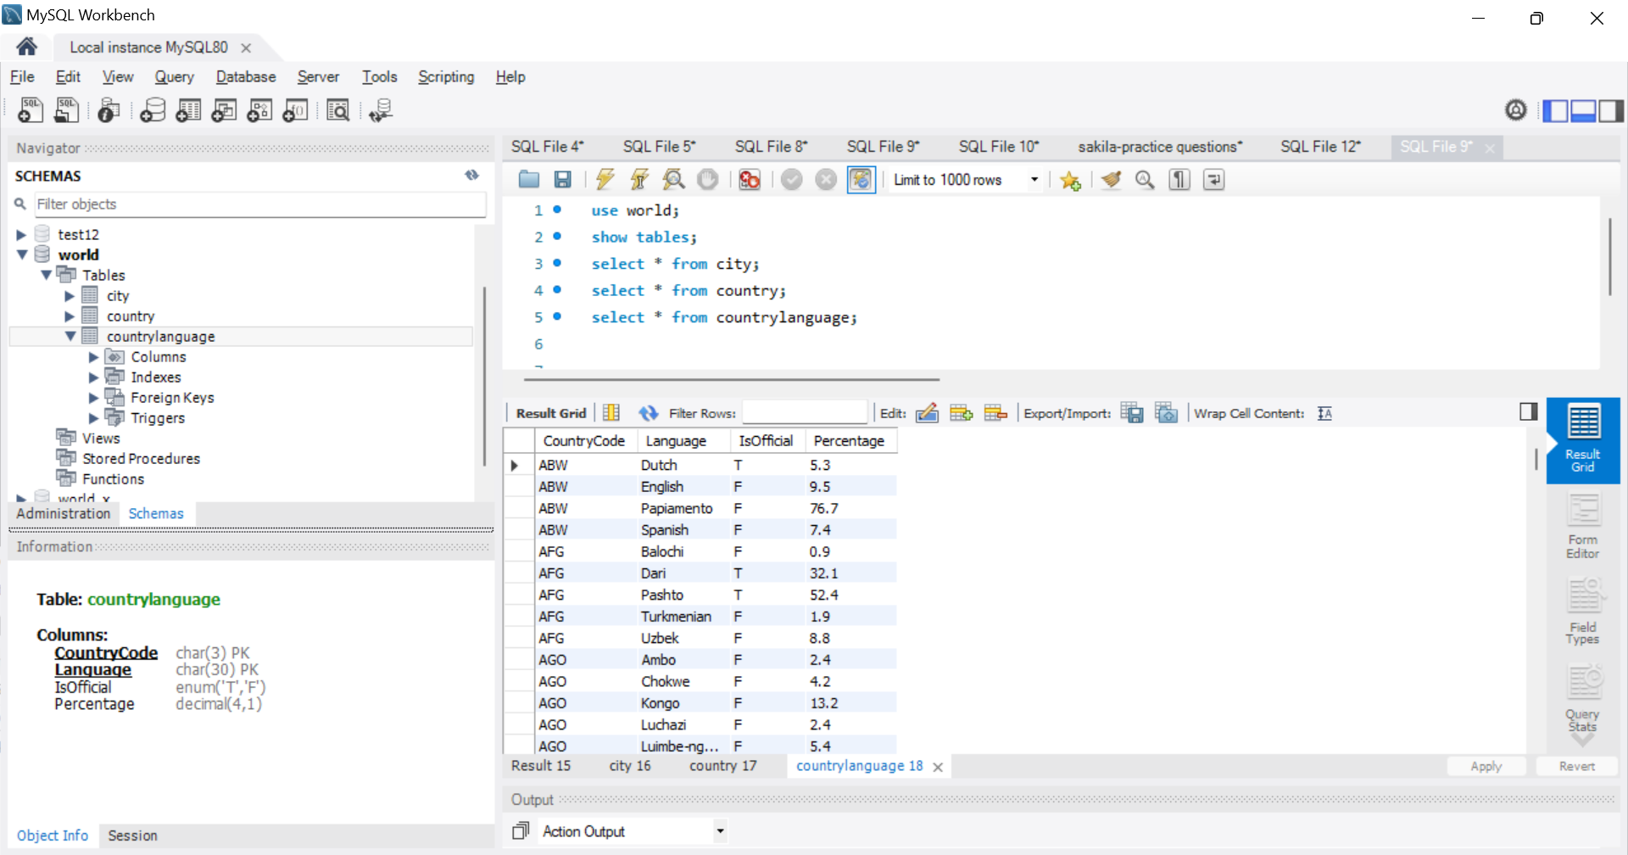

1. How can you view all tables in the world database?

Show tables;

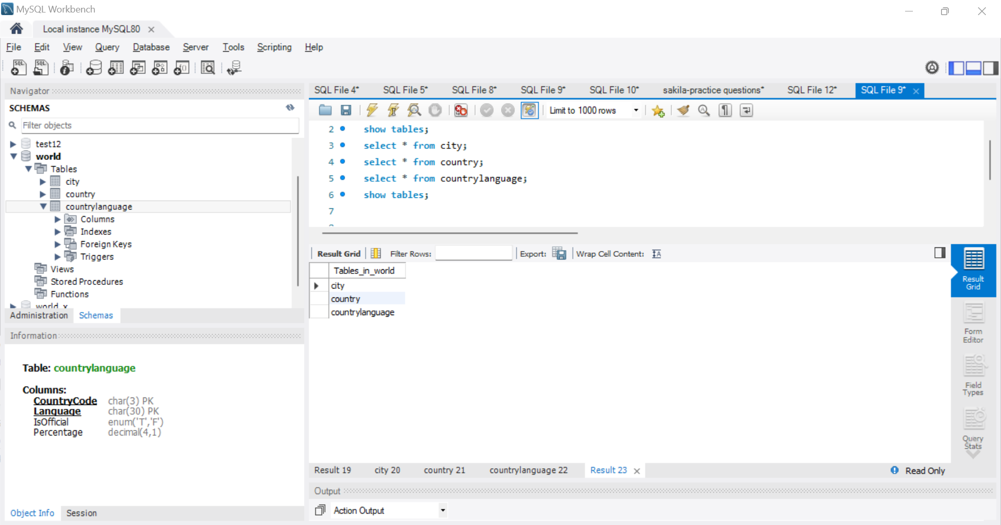

1. How do you select the world database?

The world database can be selected from the left pane SCHEMAS under which is a list of our databases.

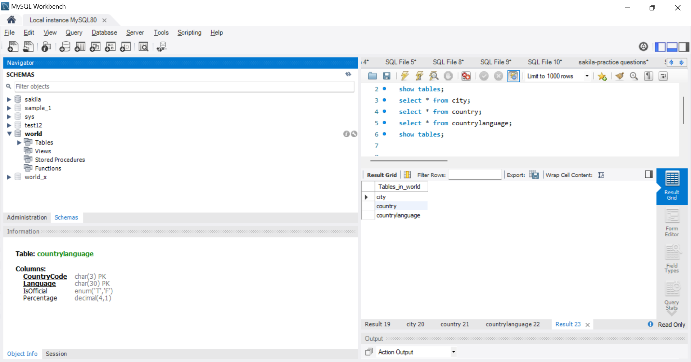

1. How do you describe the structure of the city table?

The structure of the city table is structural with five columns. Data value of columns ID and population are integer and columns name, countrycode and district are text. There are no null values.

1. How do you list all cities in the city table?

Select name from city;

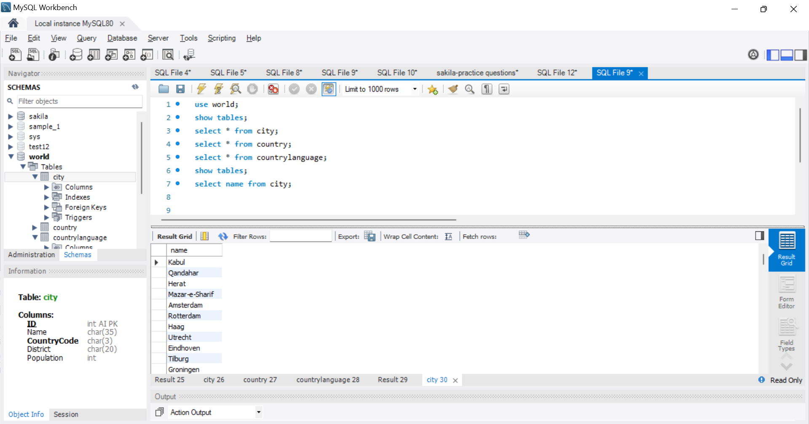

1. How do you find the number of rows in the country table?

Select count(\*) from country;

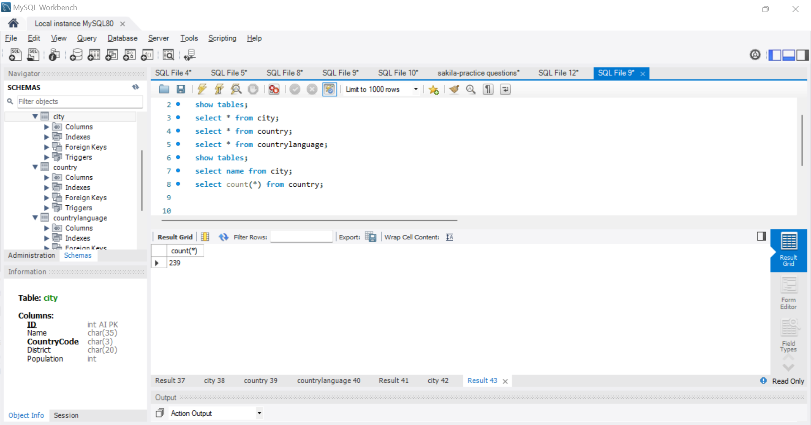

1. How do you find the population of a specific city?

Select name, population from city;

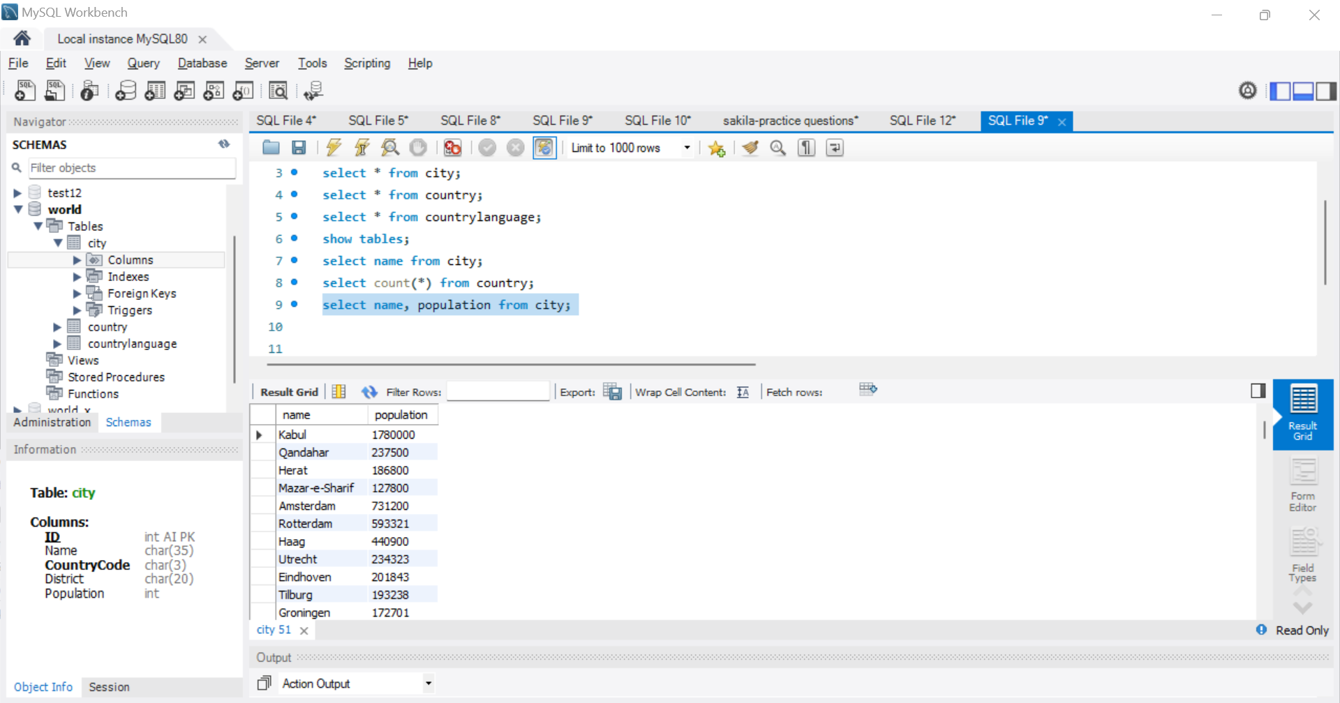

1. How do you insert a new city into the city table?

insert into city (ID, name, CountryCode, District, Population)

values (100001,"Tokyo",81,"Southern Kanto",14180000);

This code is not working but is correct.

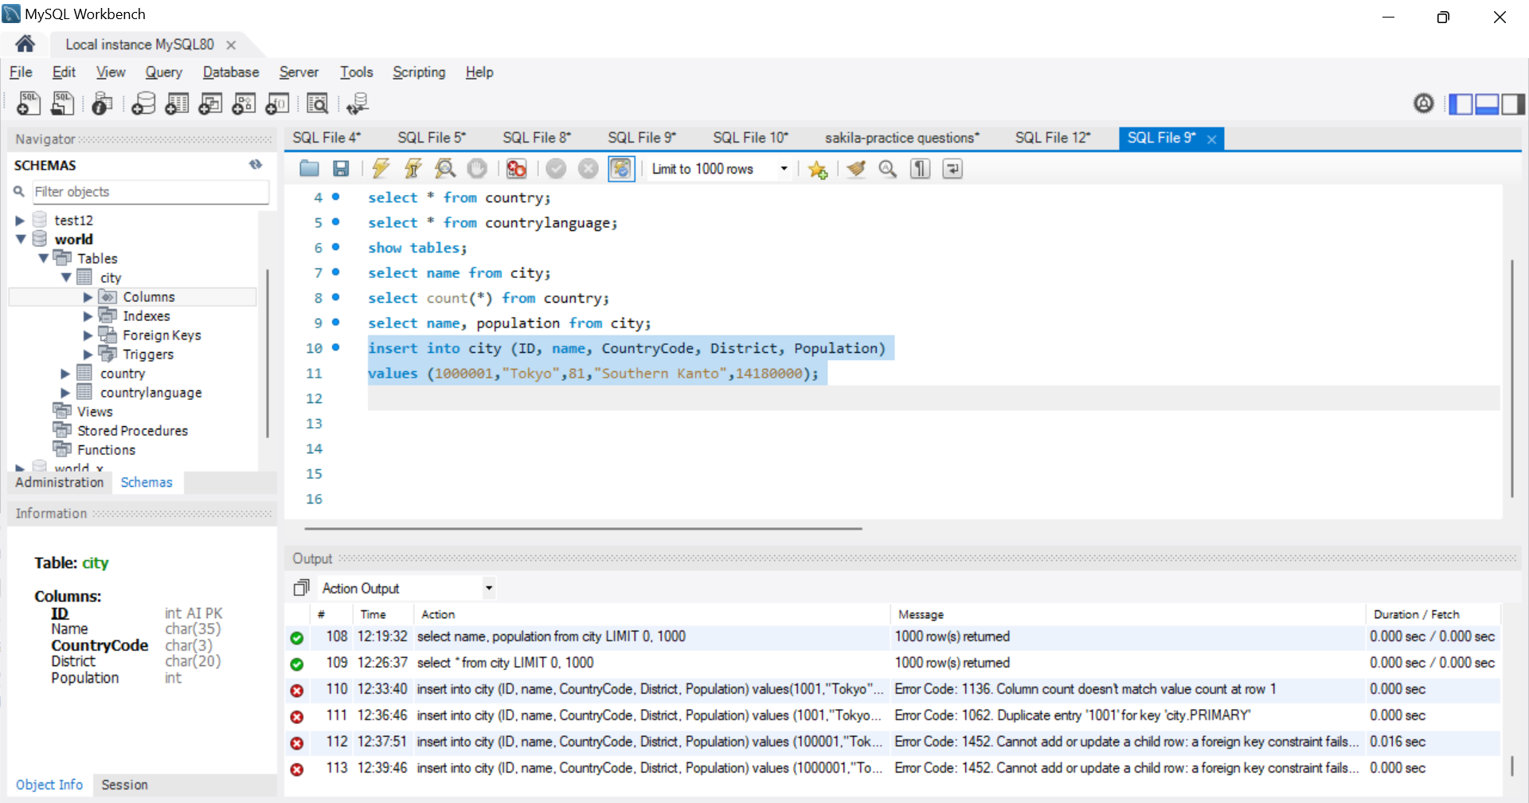

1. How do you delete a city from the city table?

Delete name from city;

I didn’t delete any record hence no a screenshot.

1. How do you update the population of a city?

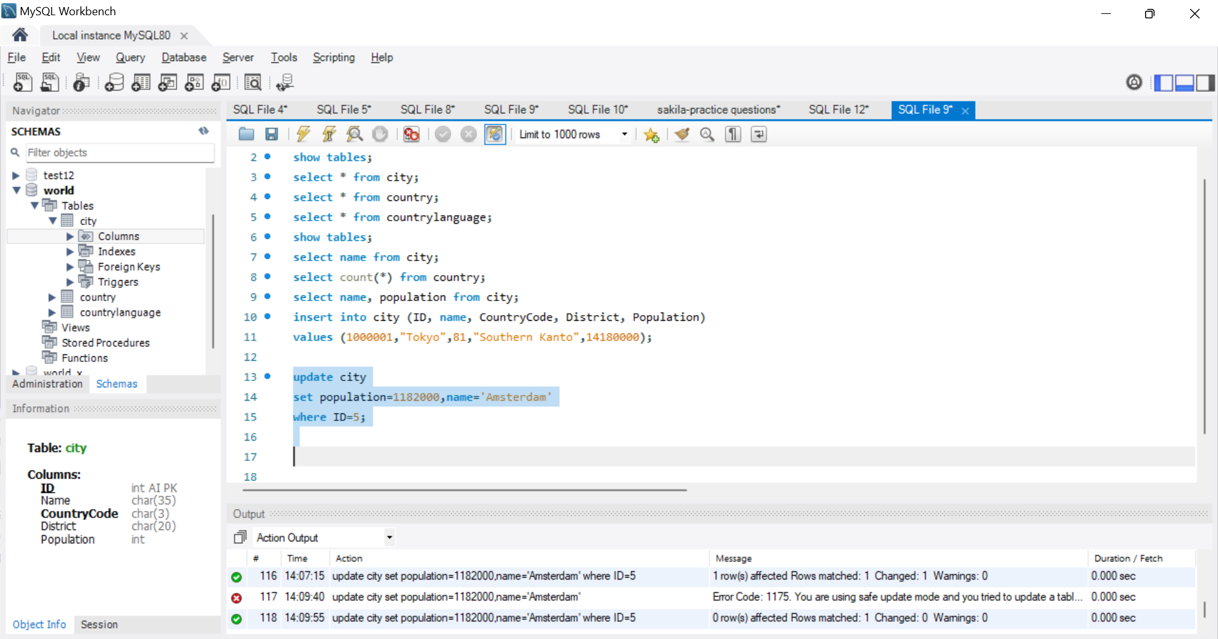

1. How do you find all countries in a specific continent?

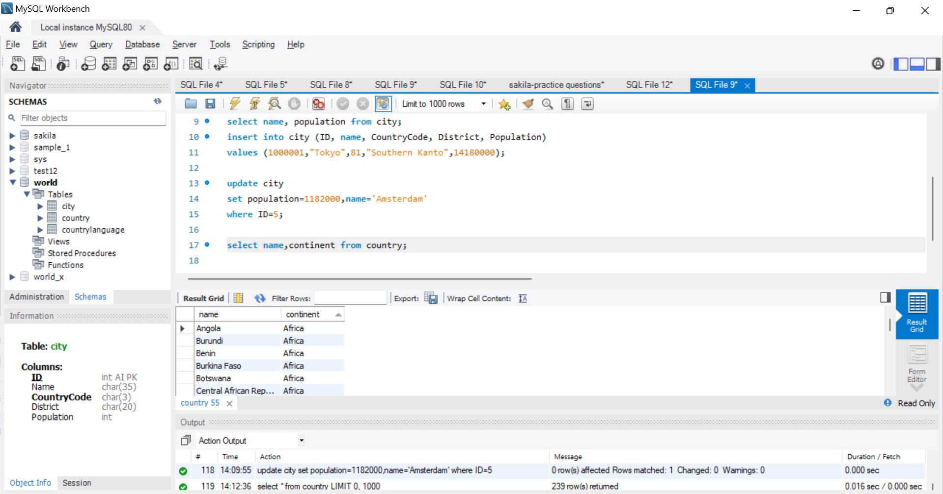

1. How do you find the capital city of a country?

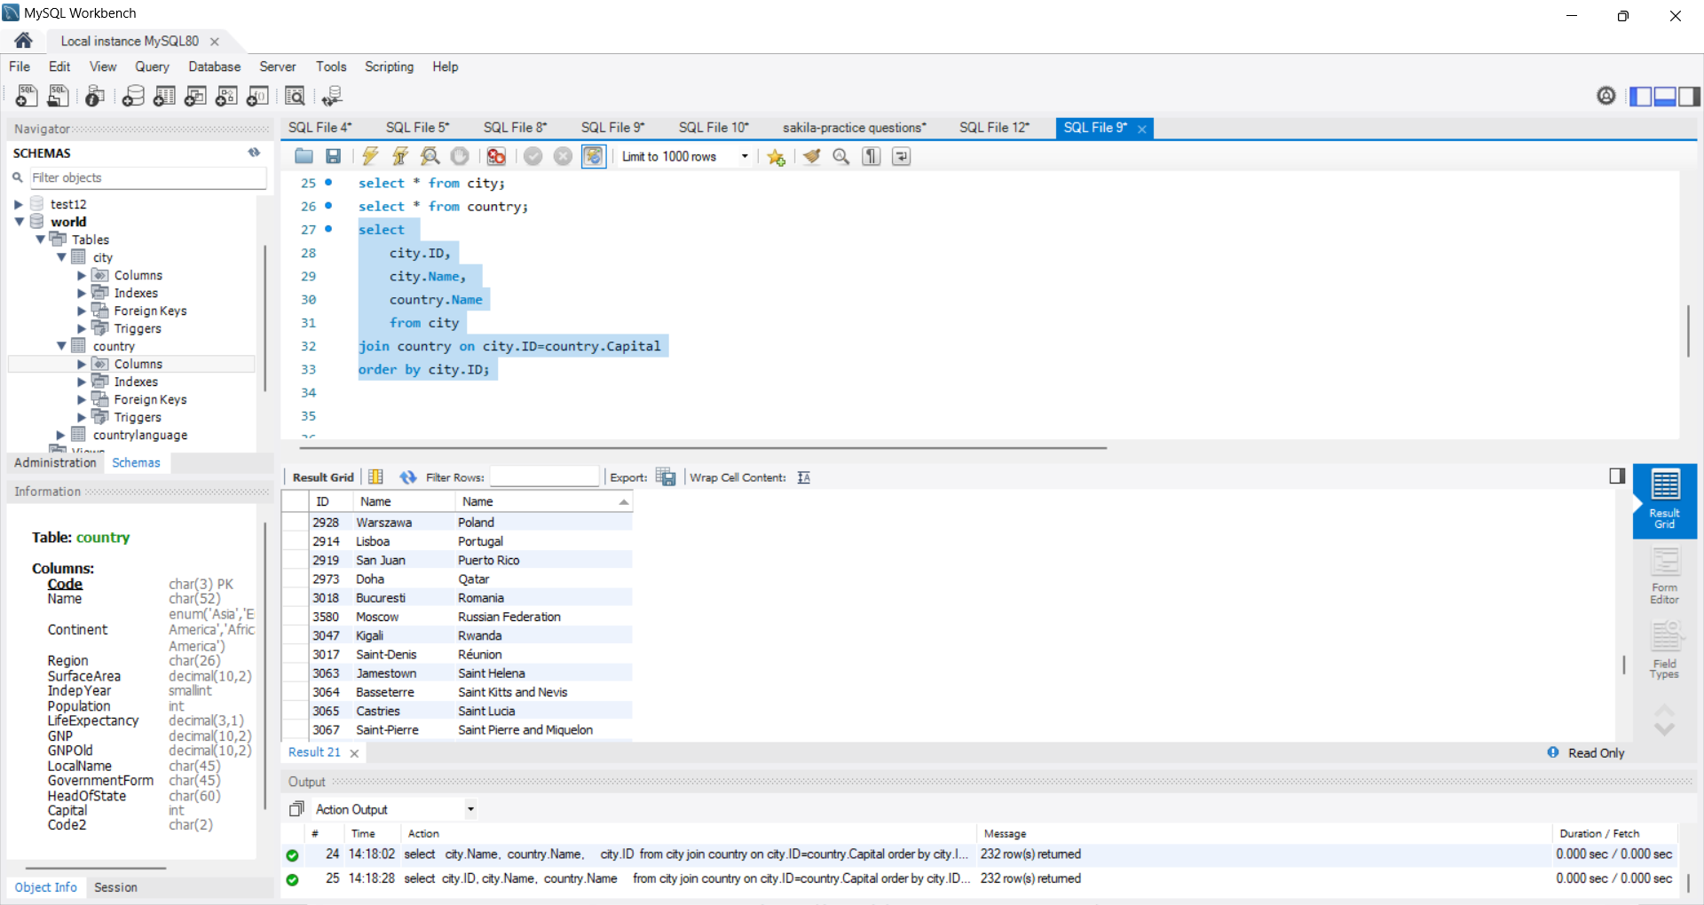

1. How do you find all languages spoken in a specific country?

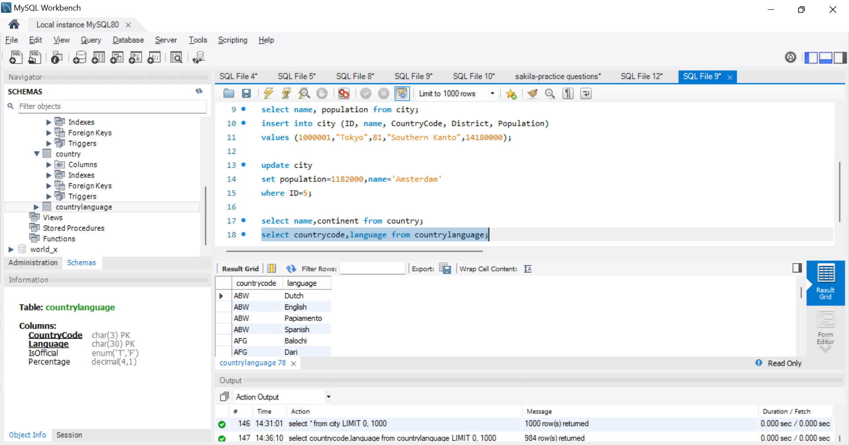

1. How do you find the official languages of a country?

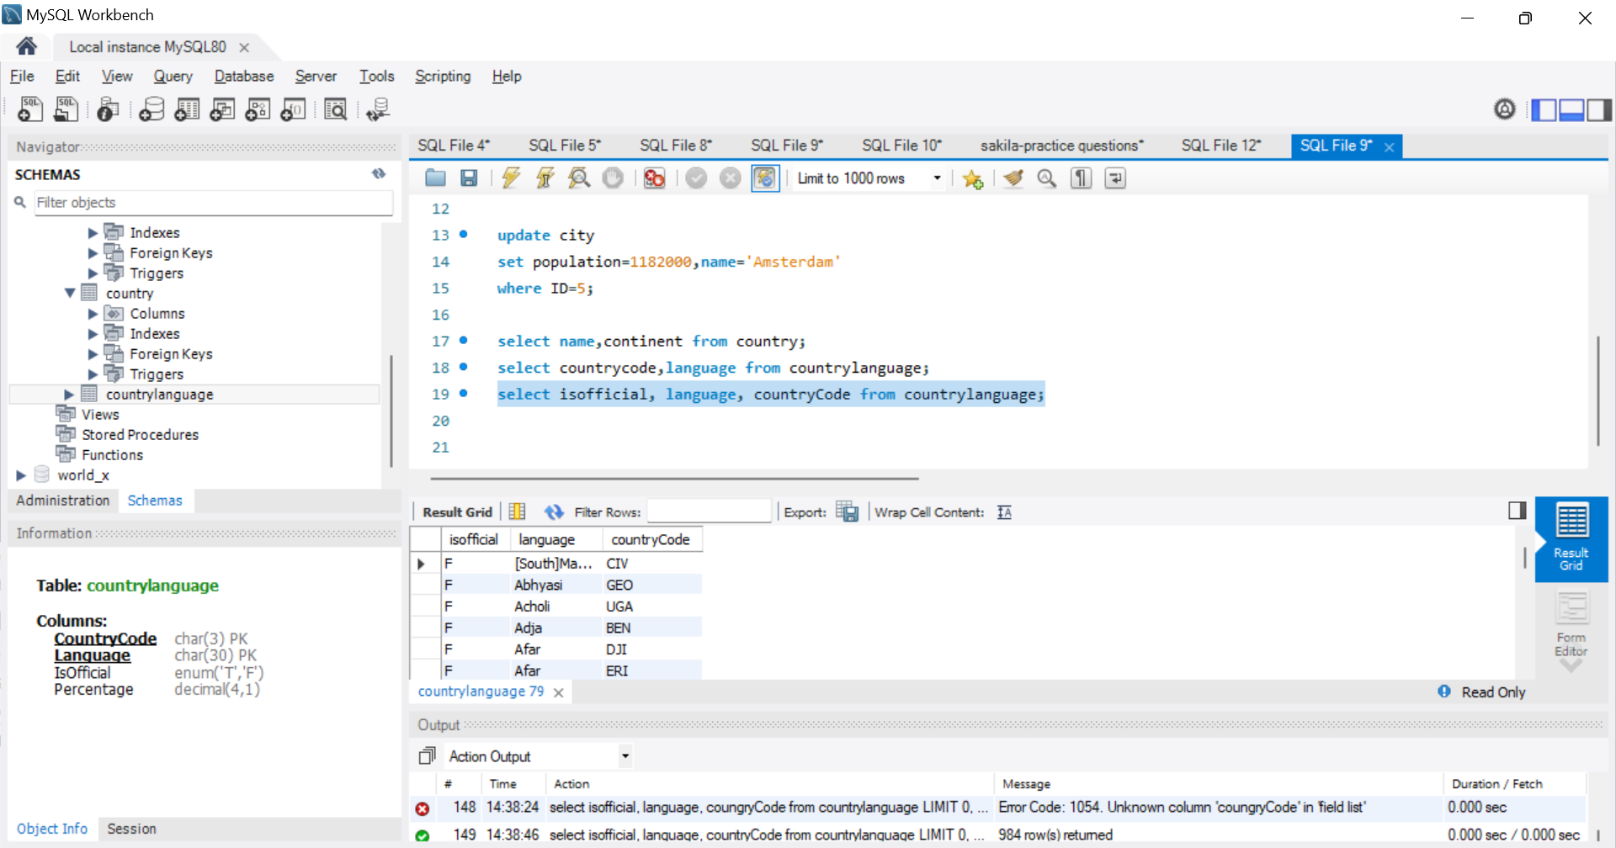

1. How do you find the countries with a population greater than 100 million?

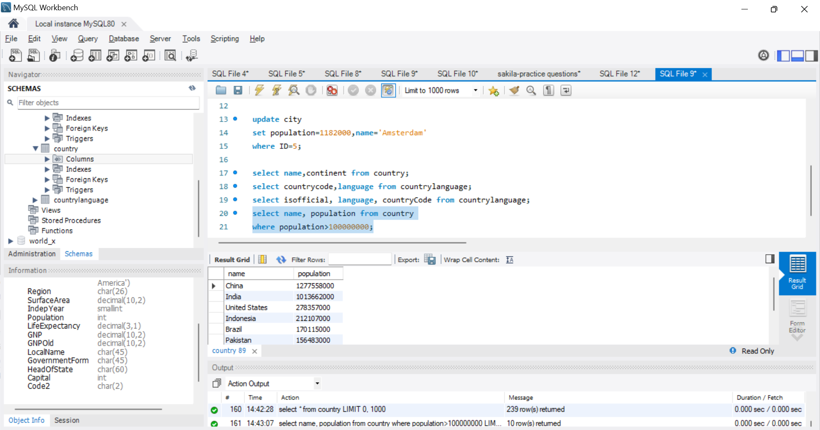

1. How do you find the countries in the 'Asia' continent?

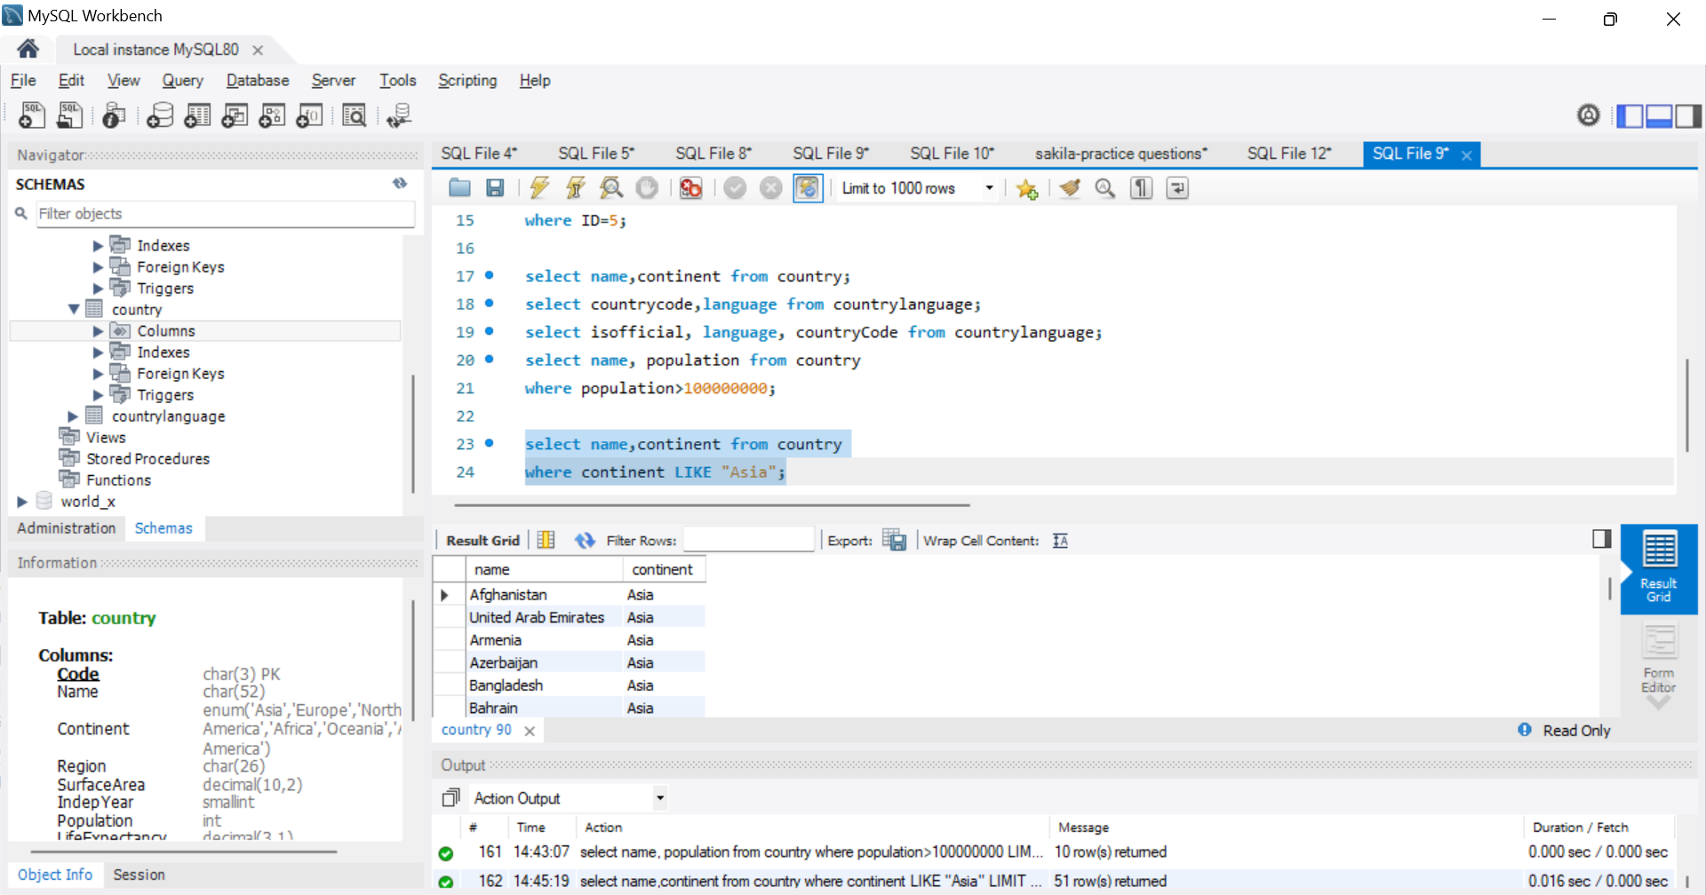

1. How do you find the average population of all cities?

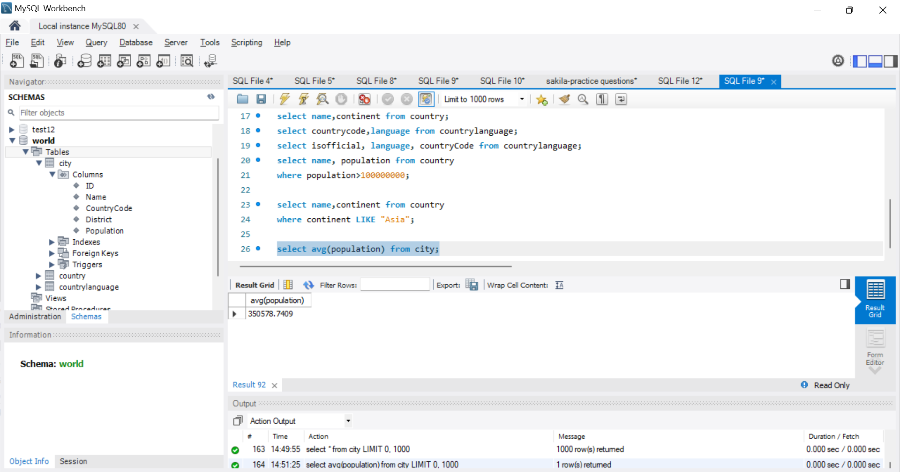

22. How do you find the total population of a specific country?

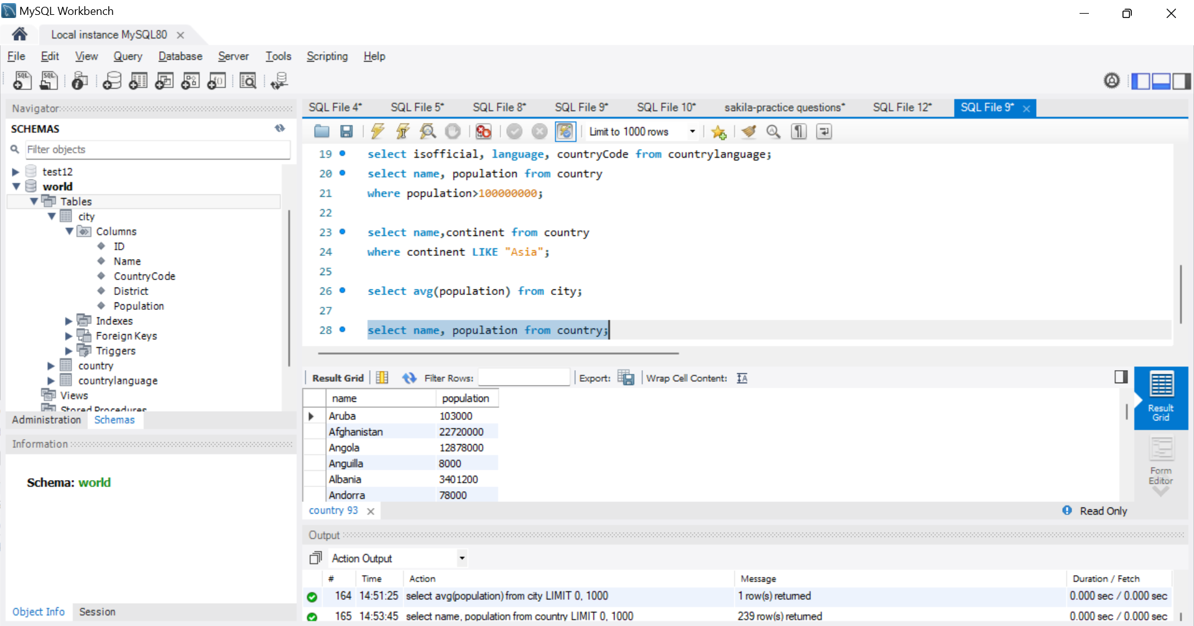

1. How do you find the number of cities in each country?

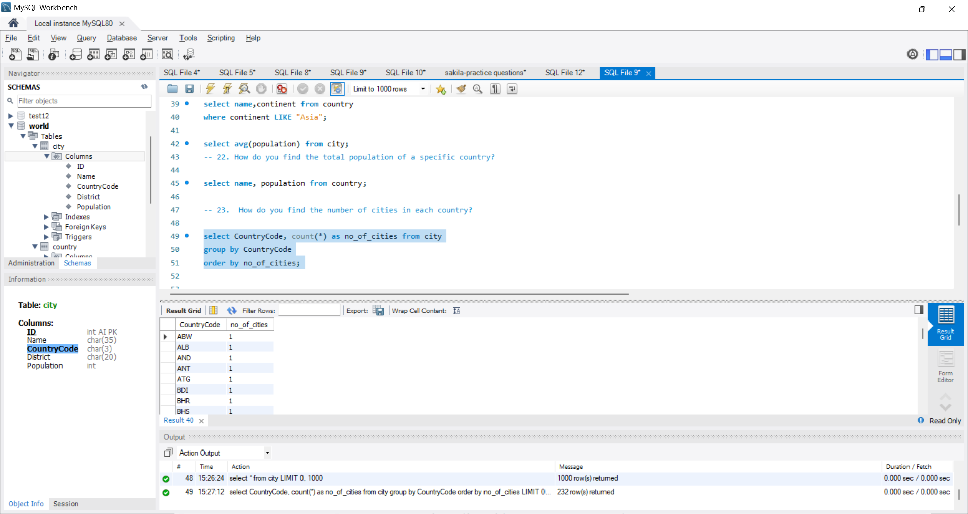

1. How do you find the top 5 most populated countries?

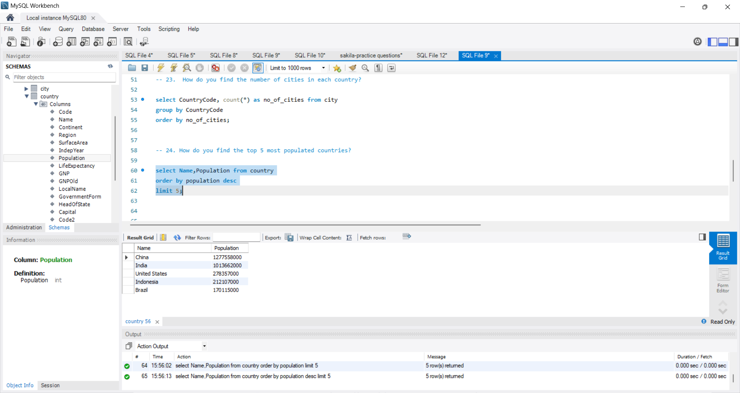

1. How do you find the least populated city?

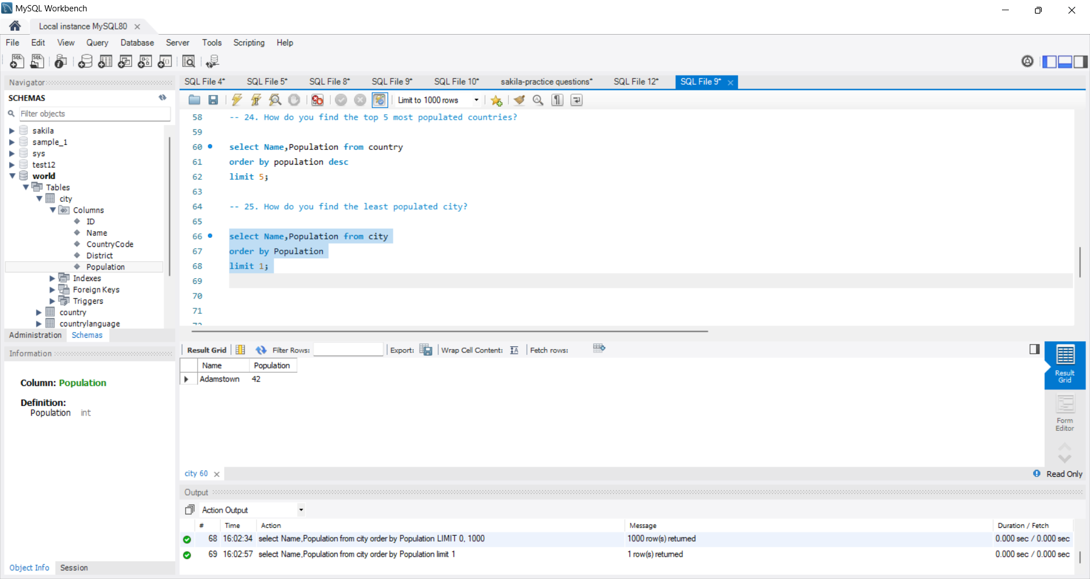

26. How do you find the countries with a life expectancy greater than 80 years?

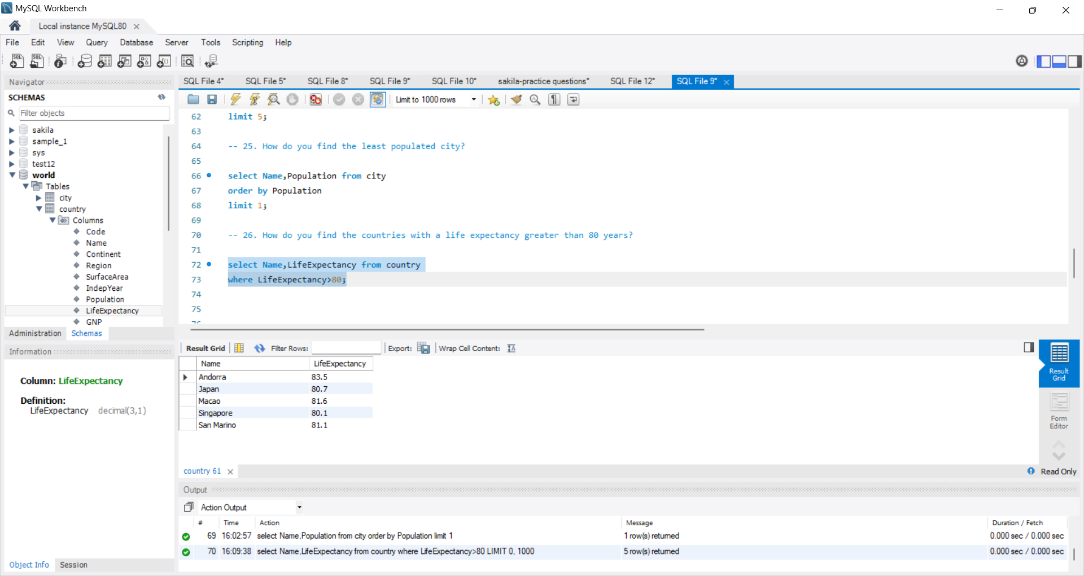

1. How do you find the countries with a GNP greater than 1 trillion?

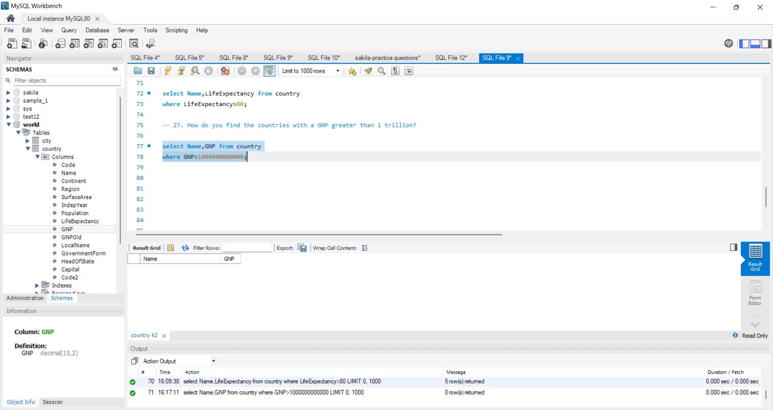

1. How do you find the countries that gained independence after 1950?

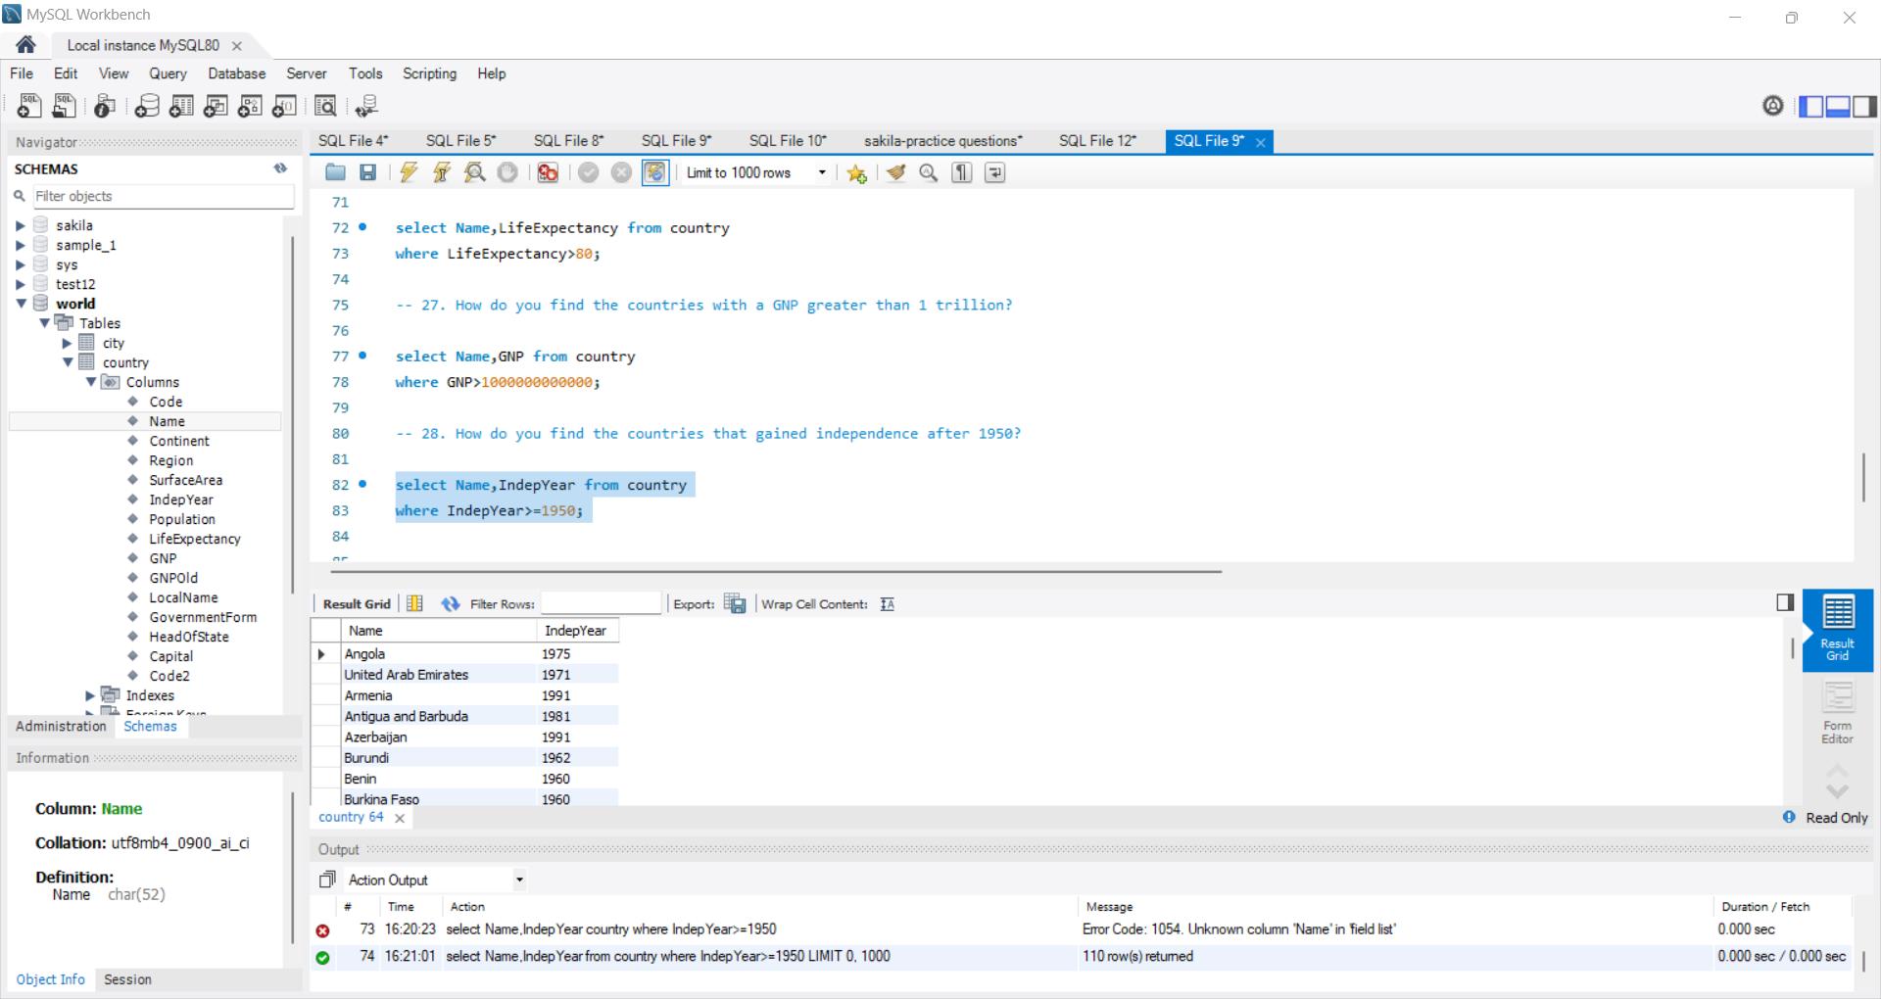

1. How do you find the countries with more than one official language?

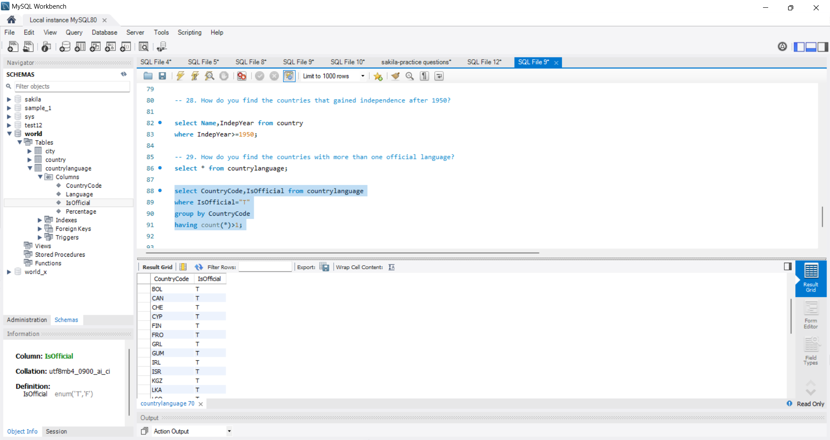

1. How do you find the cities in the 'California' district?

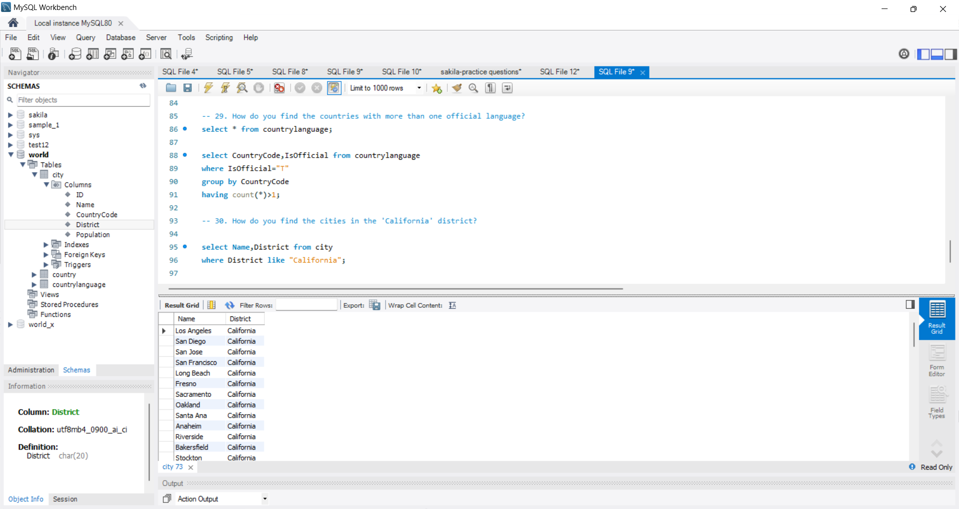

31. How do you find the countries with the highest population density?

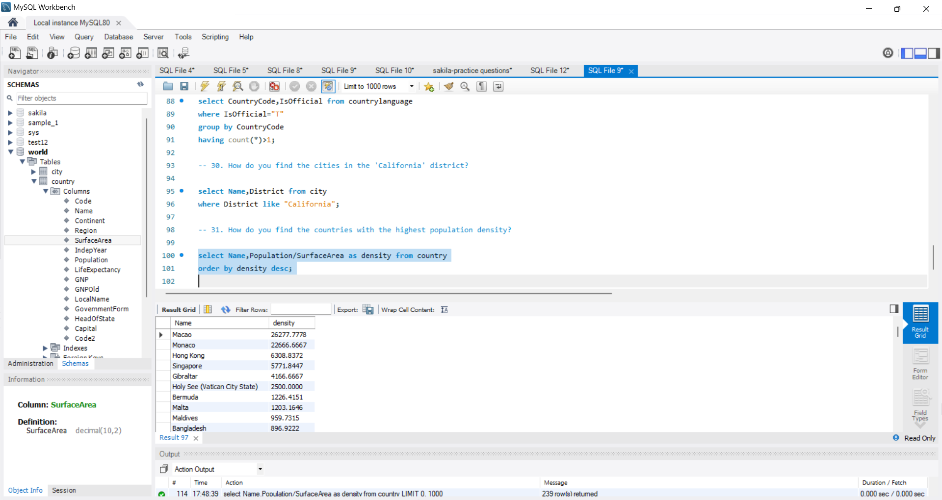

1. How do you find the countries with the lowest population density?

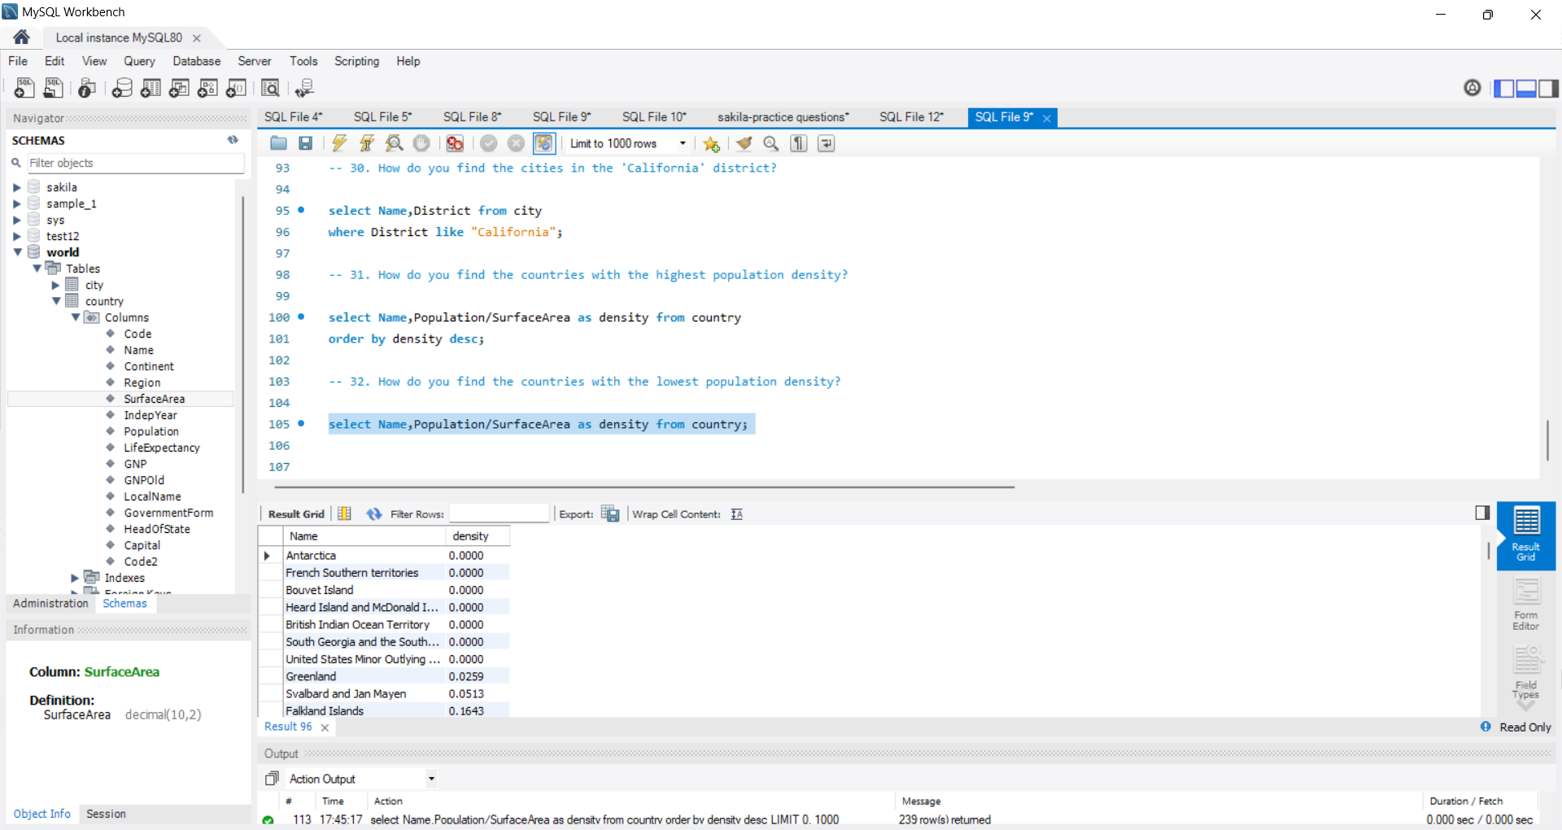

1. How do you find the countries with the highest GDP per capita?

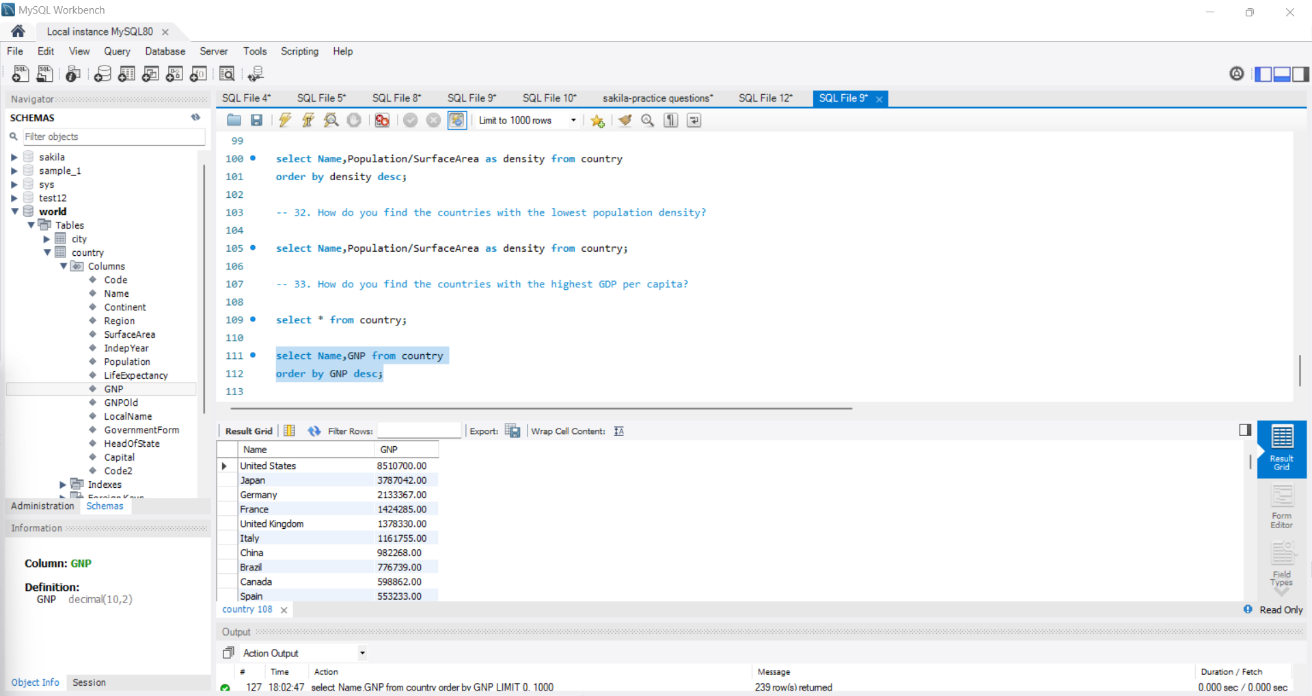

1. How do you find the countries with the lowest GDP per capita?

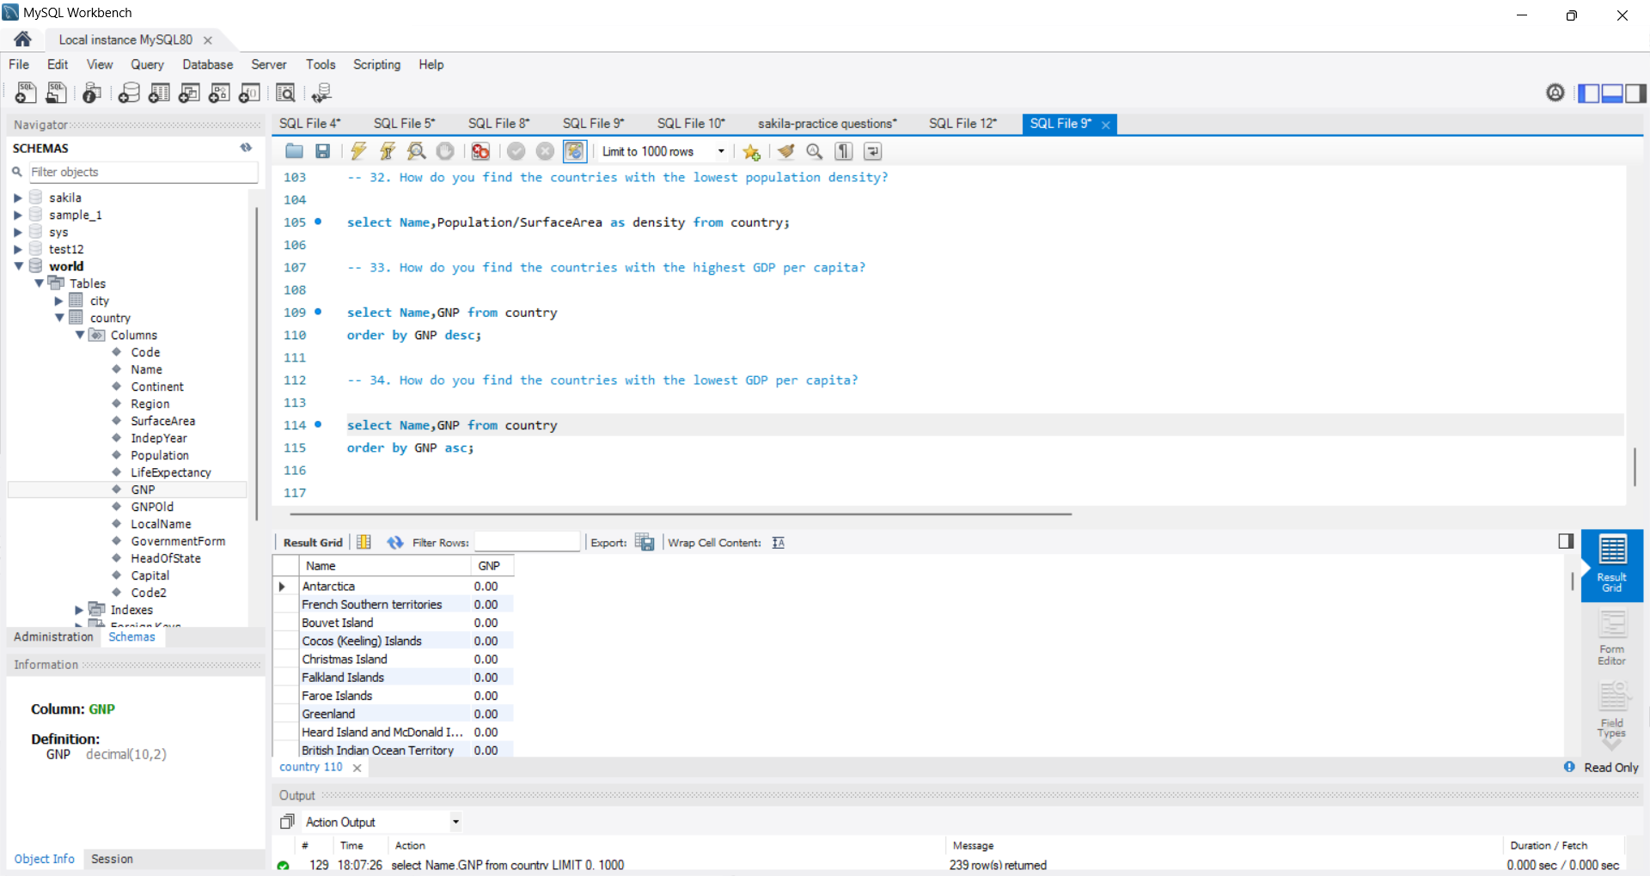

1. How do you find the countries with more than 5 official languages?

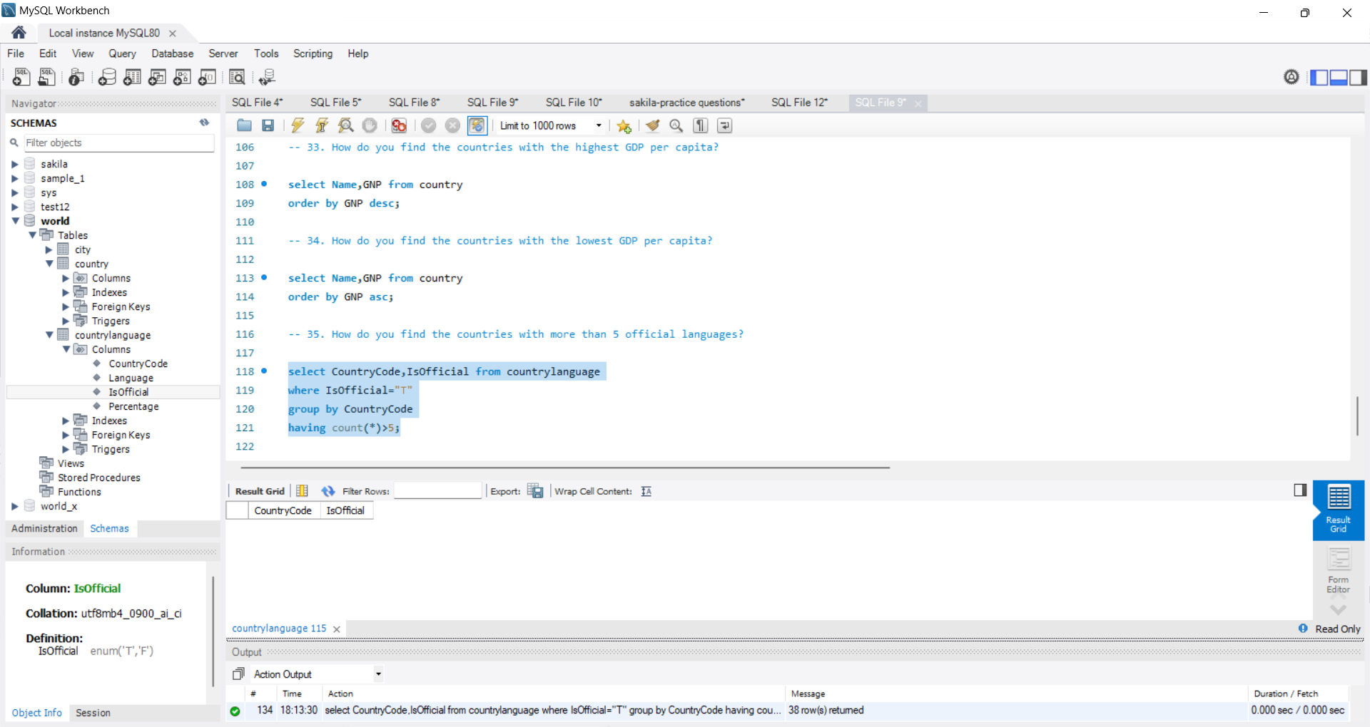

1. How do you find the countries with the highest life expectancy?

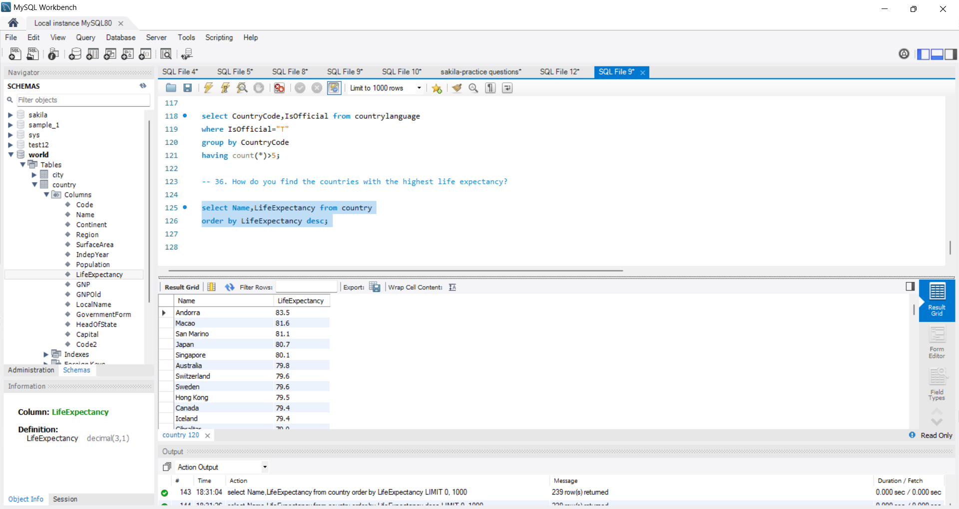

1. How do you find the countries with the lowest life expectancy?

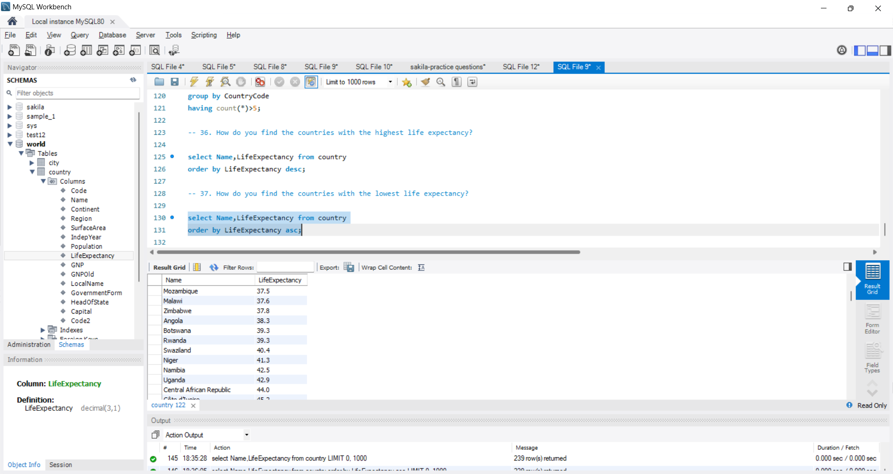

38. How do you find the countries with the most cities?

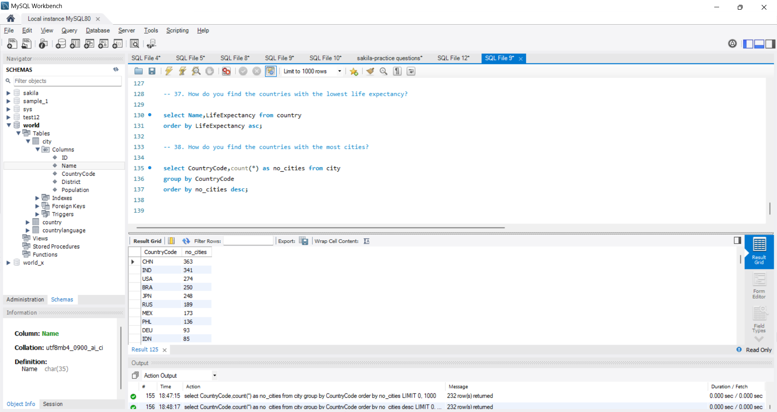

1. How do you find the countries with the least cities?

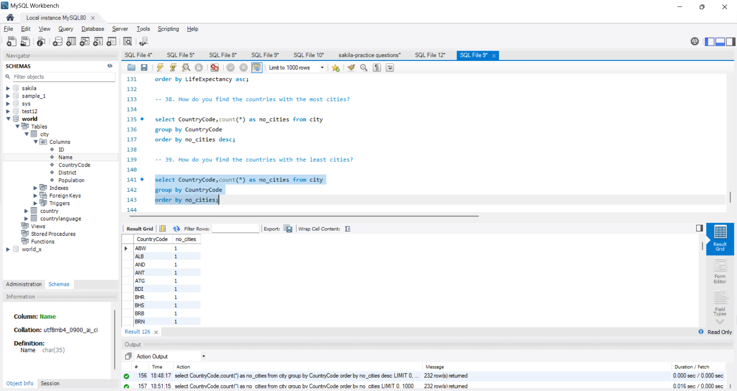

40. How do you find the countries with the highest number of languages spoken?

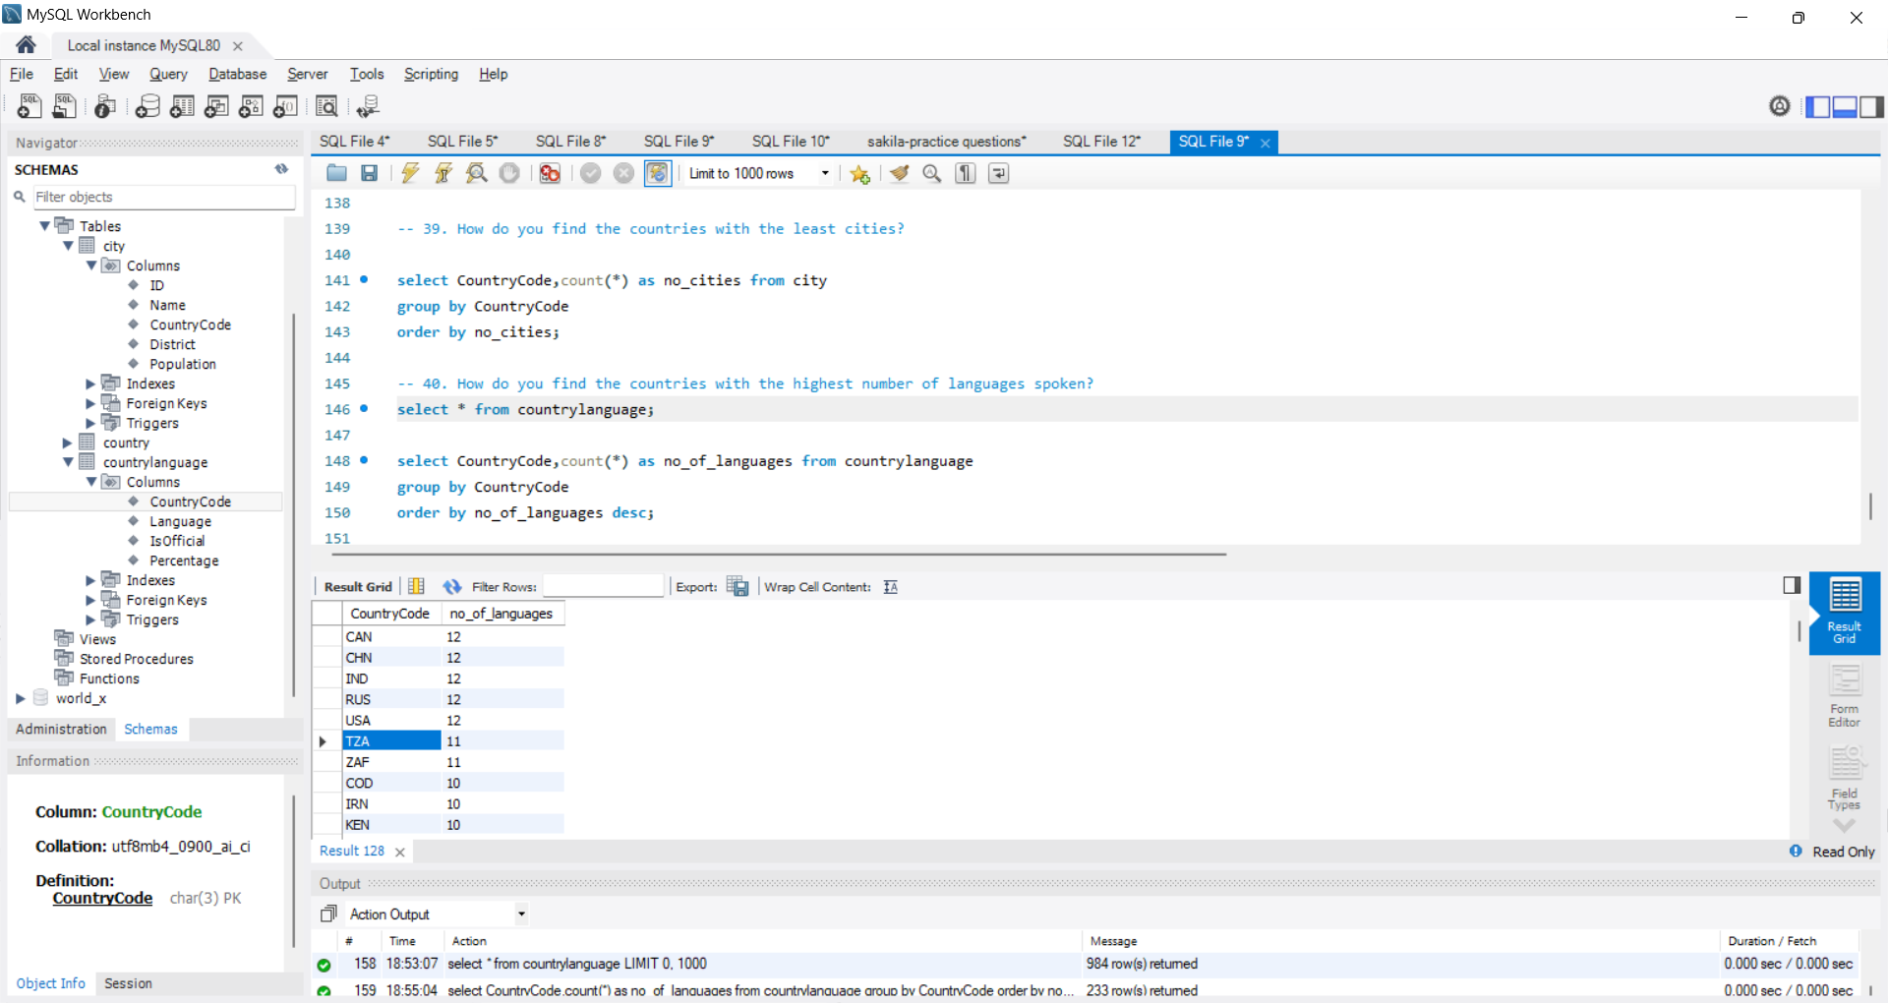

41. How do you find the population of countries with an official language of English?

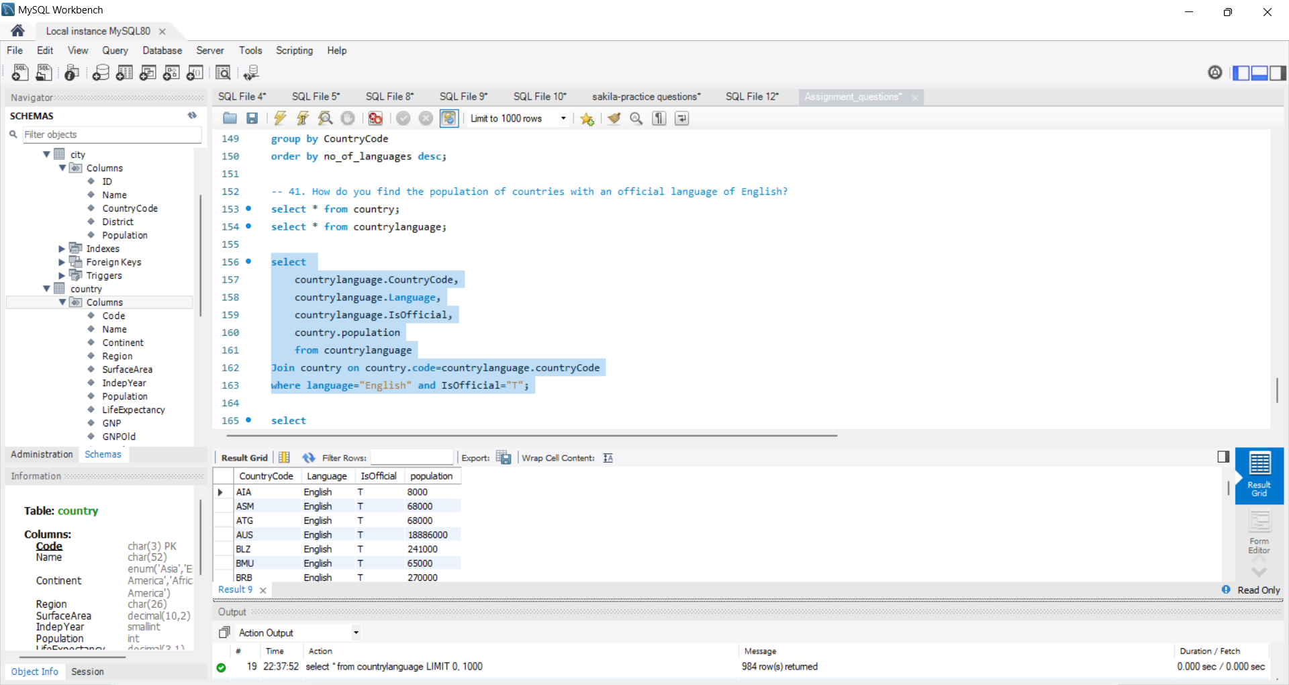

42. How do you find the top 5 most populated cities?

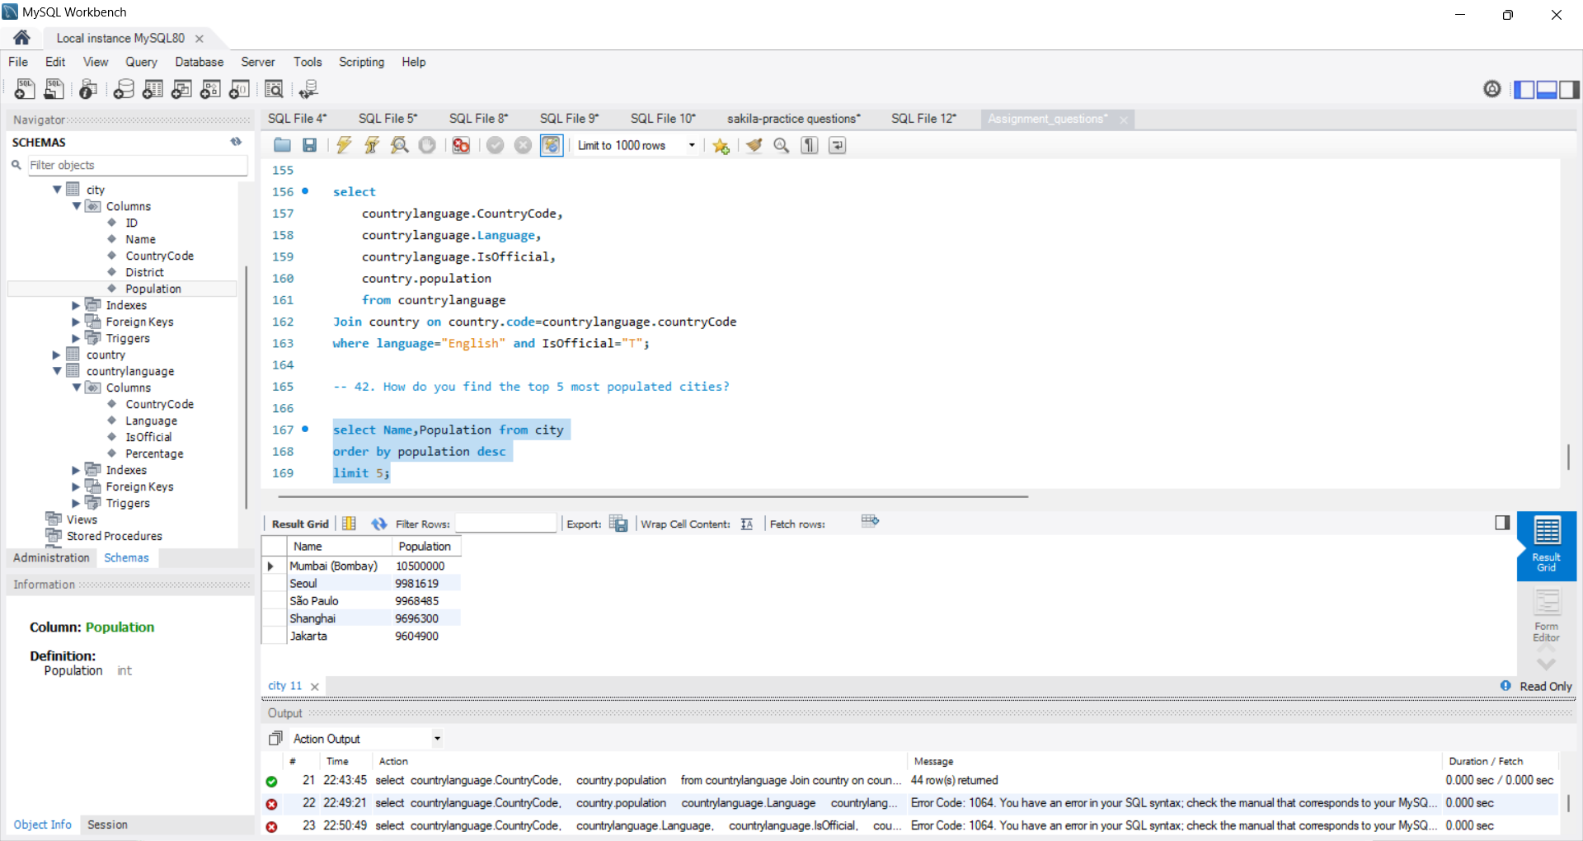

44. How do you find the countries with the highest number of official languages?

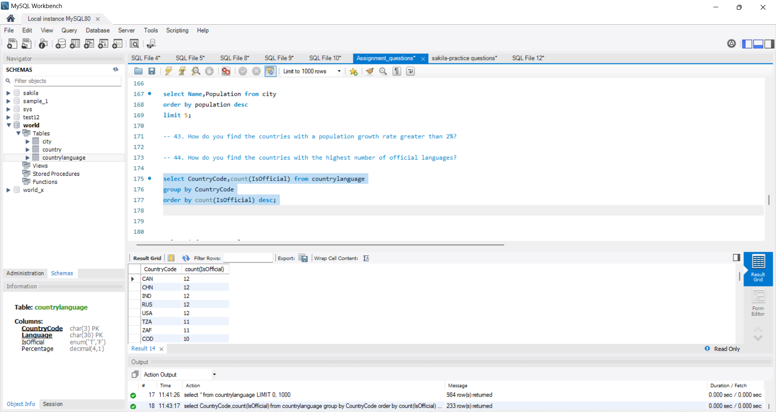

46. How do you find the countries with the highest number of cities with a population over 1 million?

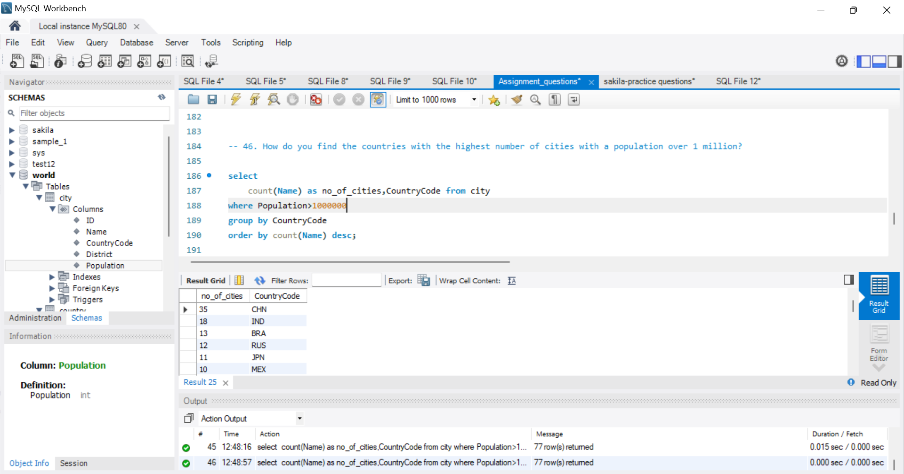

47. How do you find the countries with the highest number of cities with a population under 1 million?

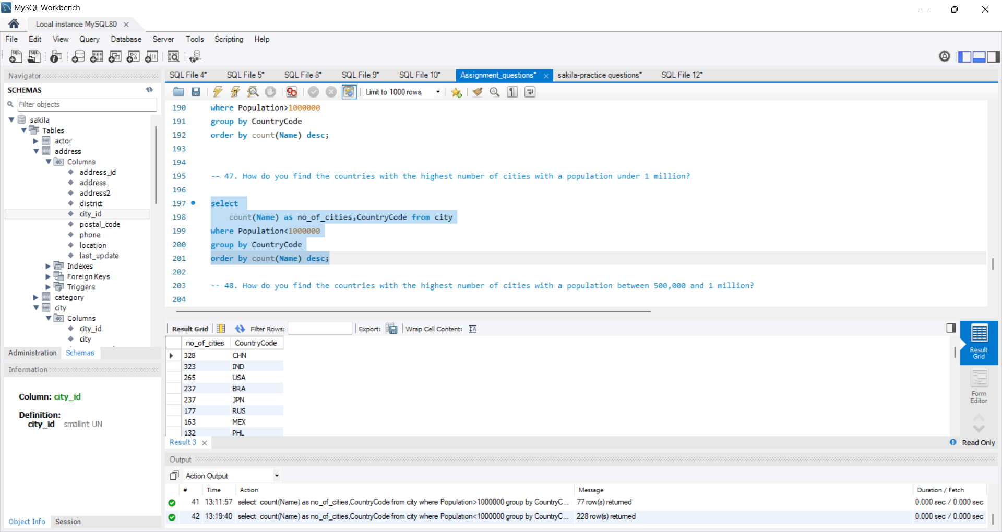

48. How do you find the countries with the highest number of cities with a population between 500,000 and 1 million?

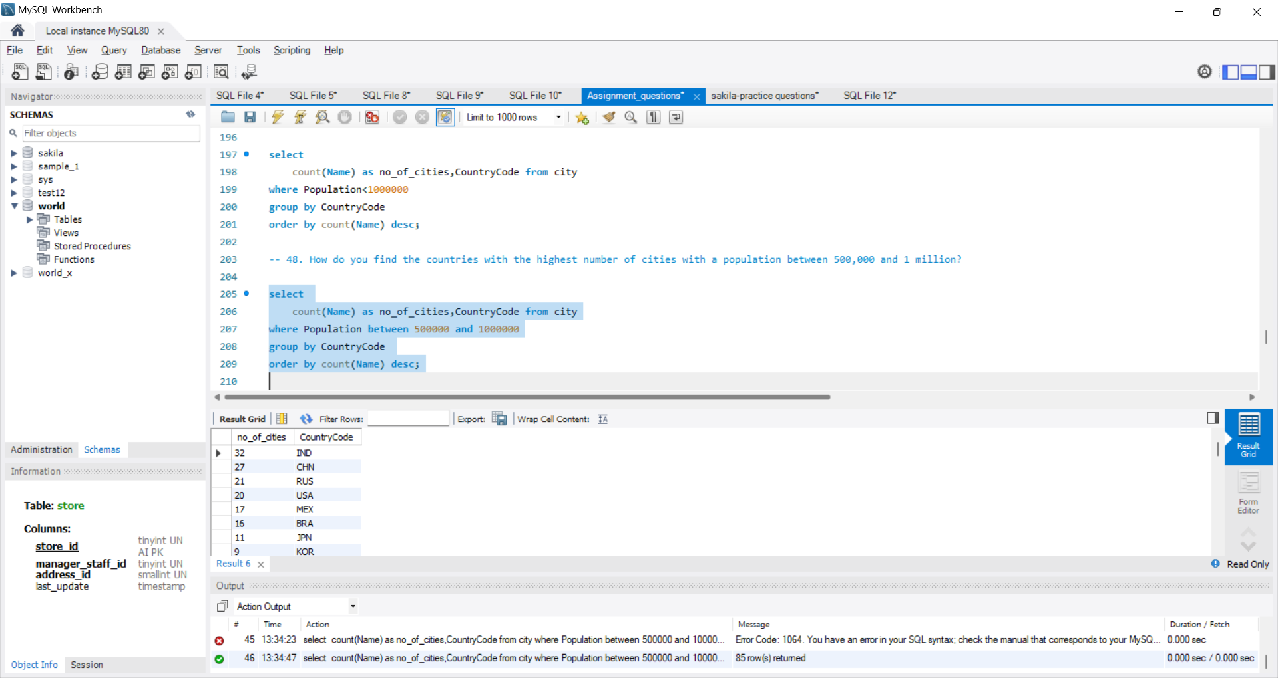

49. How do you find the countries with the highest number of cities with a population between 100,000 and 500,000?

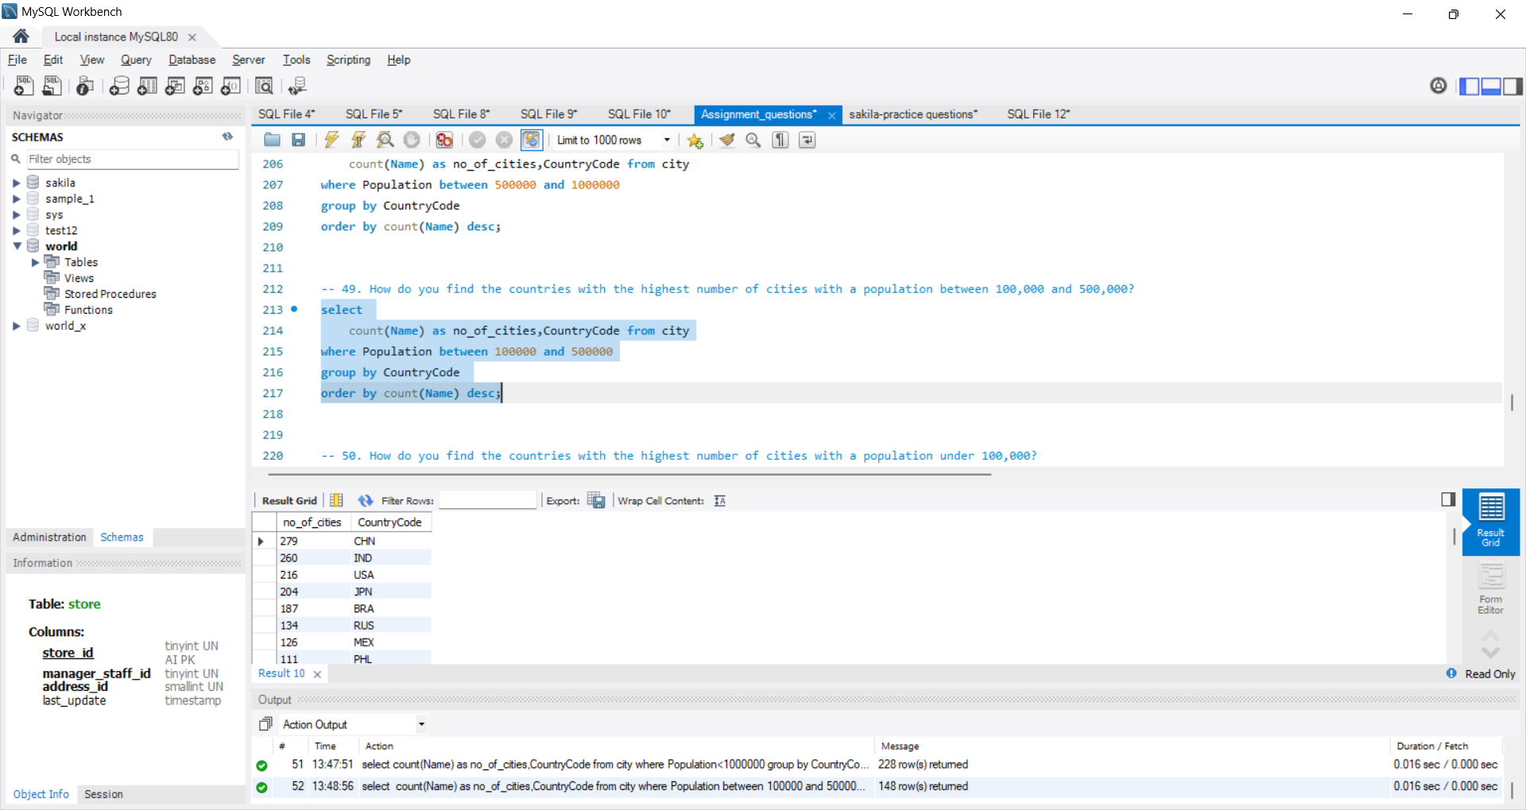

50. How do you find the countries with the highest number of cities with a population under 100,000?

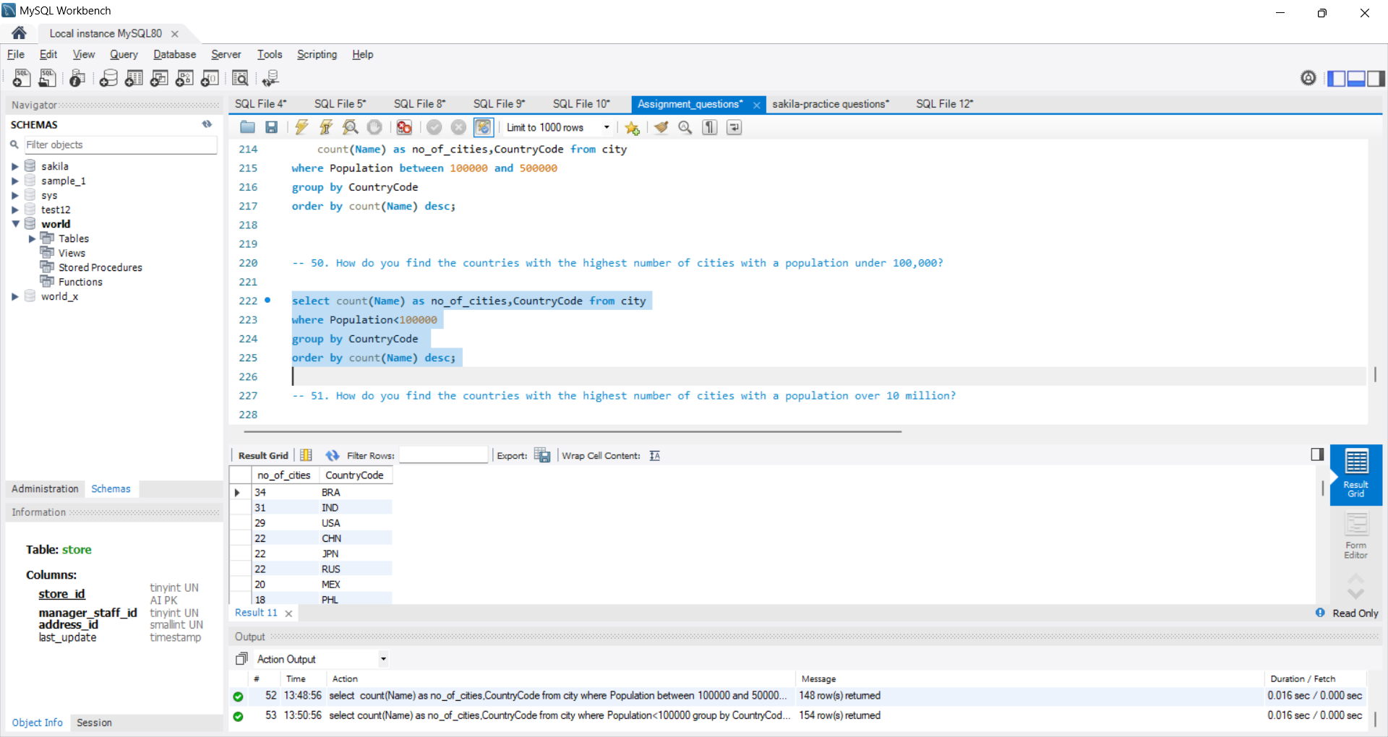

51. How do you find the countries with the highest number of cities with a population over 10 million?

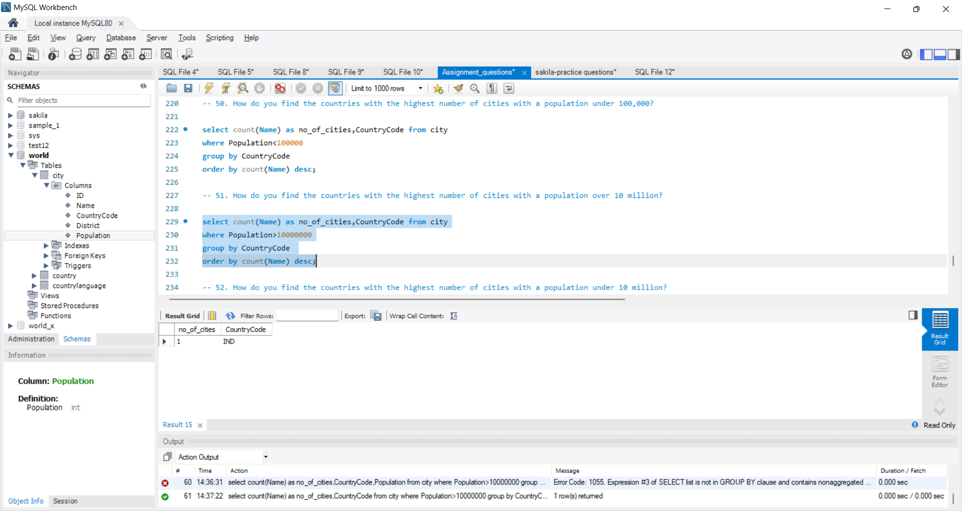

52. How do you find the countries with the highest number of cities with a population under 10 million?

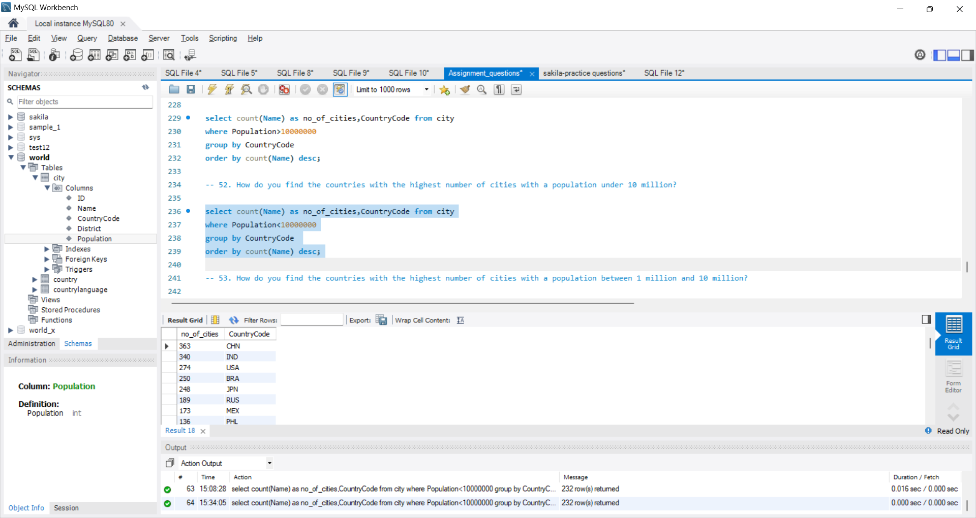

53. How do you find the countries with the highest number of cities with a population between 1 million and 10 million?

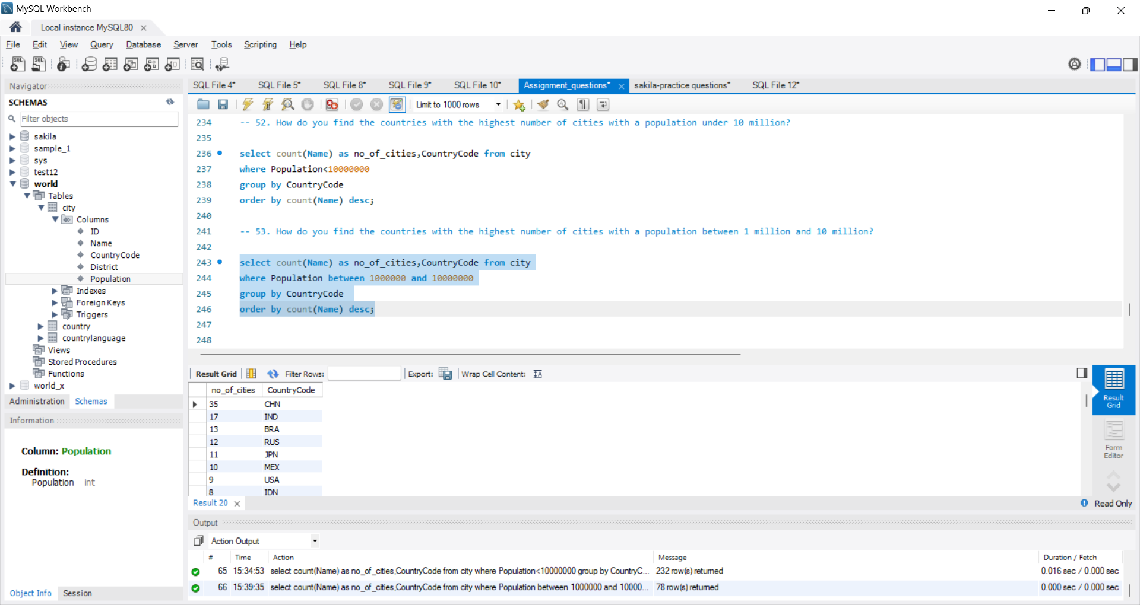

54. How do you find the countries with the highest number of cities with a population between 500,000 and 1 million?

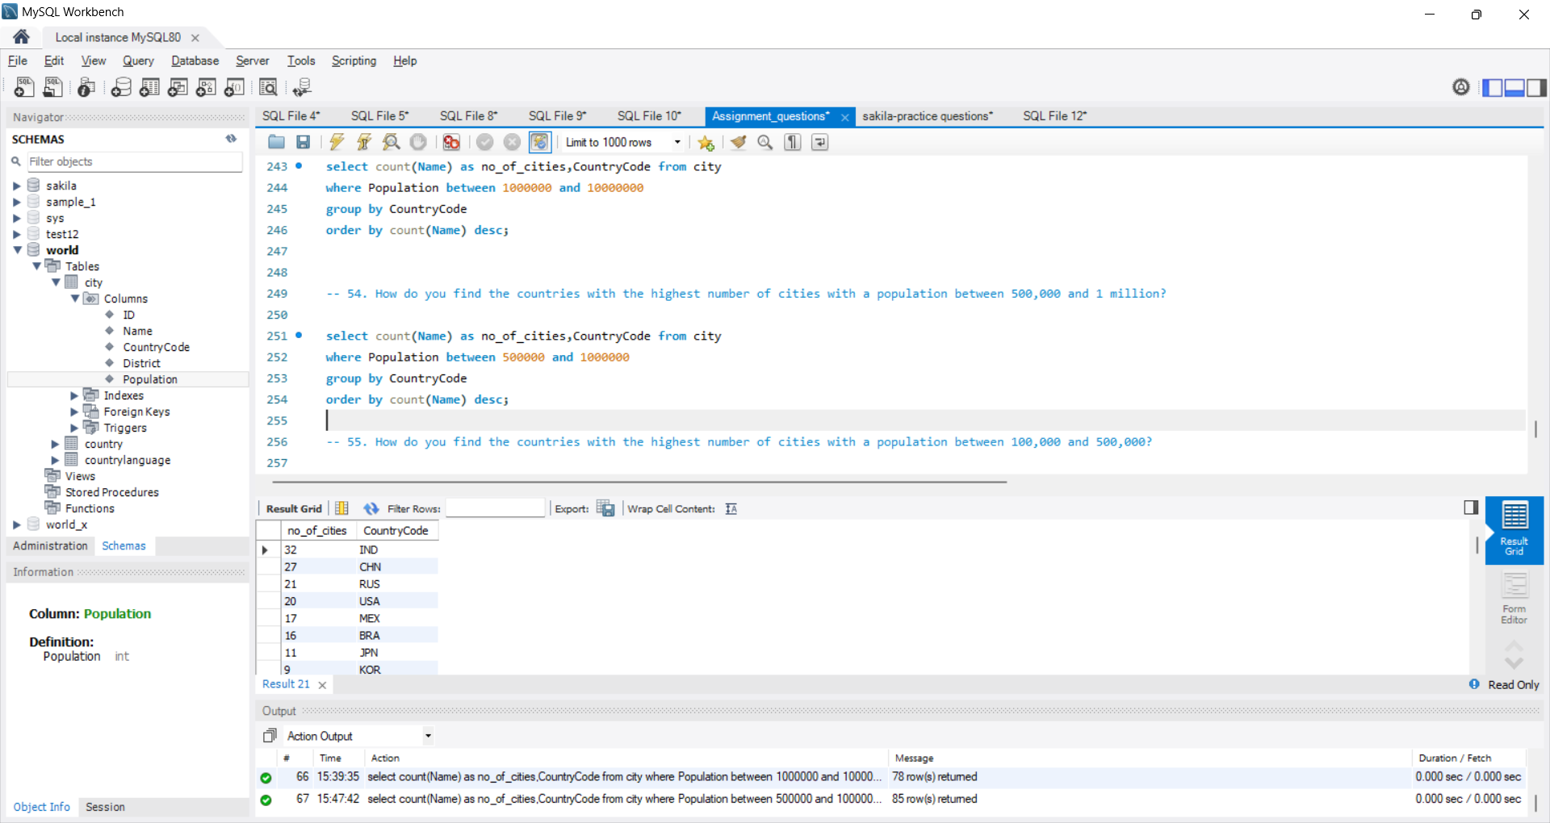

55. How do you find the countries with the highest number of cities with a population between 100,000 and 500,000?

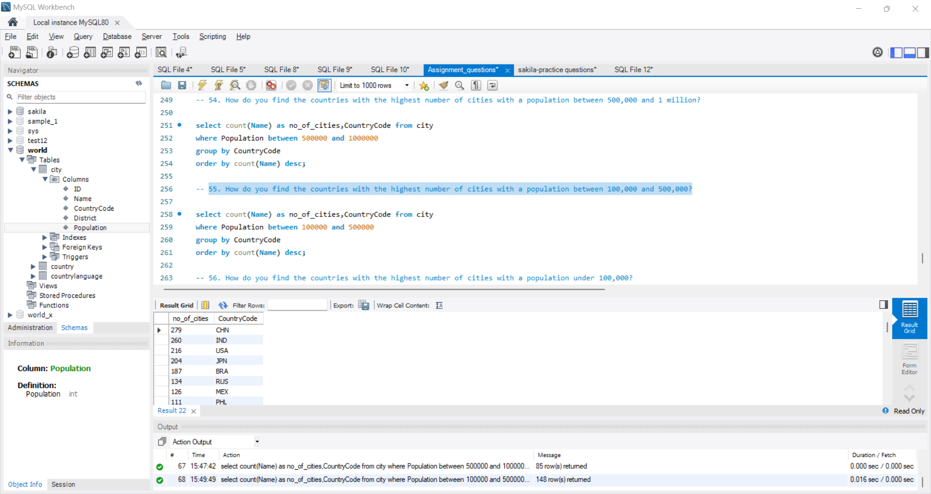

56. How do you find the countries with the highest number of cities with a population under 100,000?

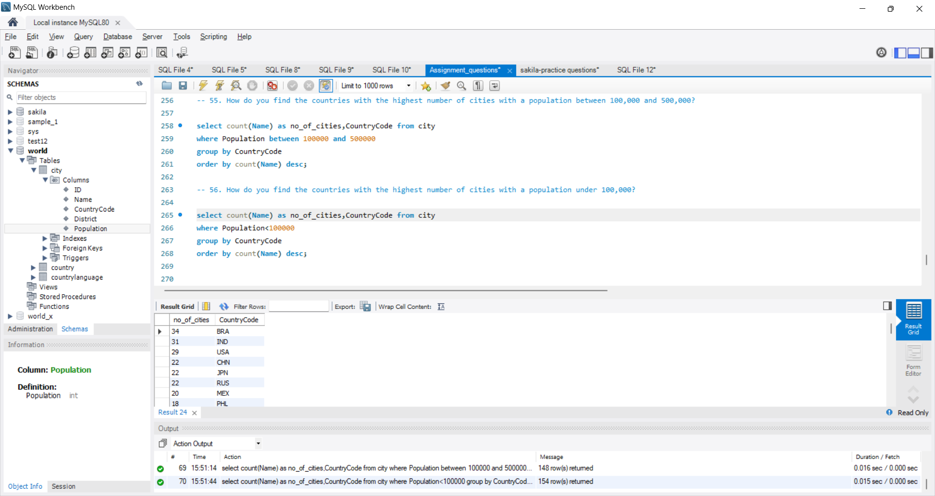

The rest of the questions are duplicates I believe, hence no answers.